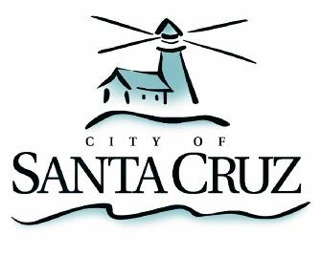

Community Programs Committee

Monday, February 13, 2012
10:00 a.m.
City Council Chambers
Santa Cruz City Hall

NOTE: Four or more Councilmembers may be present at this meeting.

A G E N D A

- Call to Order

- Public Comment on Items Not on the Agenda

- Election of the Committee Chair for 2012

- Approval of Minutes of the June 1, 2011 Meeting

- Consideration of Recommendations for the HUD Annual Action Plan—Community Development Block Grant (CDBG) Funding for FY 2013

Note: the Federal HUD budget is not yet finalized. Accordingly, the final recommended budget is subject to change.

- Overview and Discussion on the Proposed Neighborhood Revitalization Strategy Area (NRSA) for the Beach/South of Laurel area

- Establish Committee’s Spring 2012 Meeting Schedule

Adjournment -- The Community Programs Committee will adjourn from the meeting of February 13, 2012 to its next meeting at a date and time to be determined.

The City of Santa Cruz does not discriminate against persons with disabilities. Out of consideration for people with chemical sensitivities, we ask that you attend fragrance free. Upon request, the agenda can be provided in a format to accommodate special needs. Additionally, if you wish to attend this public meeting and will require assistance such as an interpreter for American Sign Language, Spanish, or other special equipment, please call the City Clerk’s Department at 420-5030 at least five days in advance so that we can arrange for such special assistance. The Cal-Relay system number: 1-800-735-2922.

