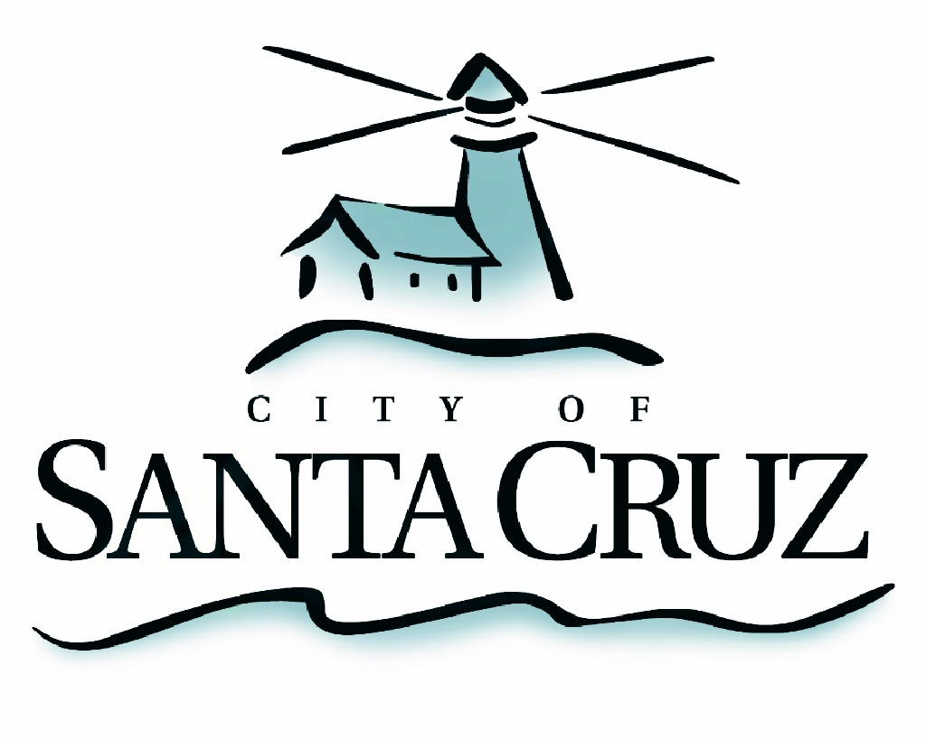

PUBLIC SAFETY COMMITTEE
REGULAR MEETING

Monday, March 26, 2012
5:00 p.m.
City Council Chambers, Santa Cruz City Hall
809 Center Street

A G E N D A

- Call to Order

- Public Comment on Items Not on the Agenda

- Approval of the Minutes of the December 12, 2011 Meeting

- Election of the 2012 Public Safety Committee Chair

- Establish 2012 Quarterly Meeting Schedule and Topics of Discussion

Date | Time | Meeting Type
June 18 | 5 p.m. | Regular
June __ | TBD | Special
September 17 | 5 p.m. | Regular
December 17 | 5 p.m. | Regular
March 11 (2012) | 5 p.m. | Regular

- Predictive Policing Update – Presentation by Police Department Staff

- Update on the San Lorenzo River Levee – Presentations by the Assistant to the City Manager and Public Works Department Staff

- Fire Department Operations and Fire Service Agreement with University of California, Santa Cruz – Presentation by Fire Department Staff

- Communications from Committee Members (Information Only)

Adjournment -- The Public Safety Committee will adjourn from the regular meeting of March 26,
2012 to its next regularly scheduled meeting of June 18, 2012.

The City of Santa Cruz does not discriminate against persons with disabilities. Out of consideration for people with chemical sensitivities, we ask that you attend fragrance free. Upon request, the agenda can be provided in a format to accommodate special needs. Additionally, if you wish to attend this public meeting and will require assistance such as an interpreter for American Sign Language, Spanish, or other special equipment, please call the City Clerk’s Department at 420-5030 at least five days in advance so that we can arrange for such special assistance. The Cal-Relay system number: 1-800-735-2922.

