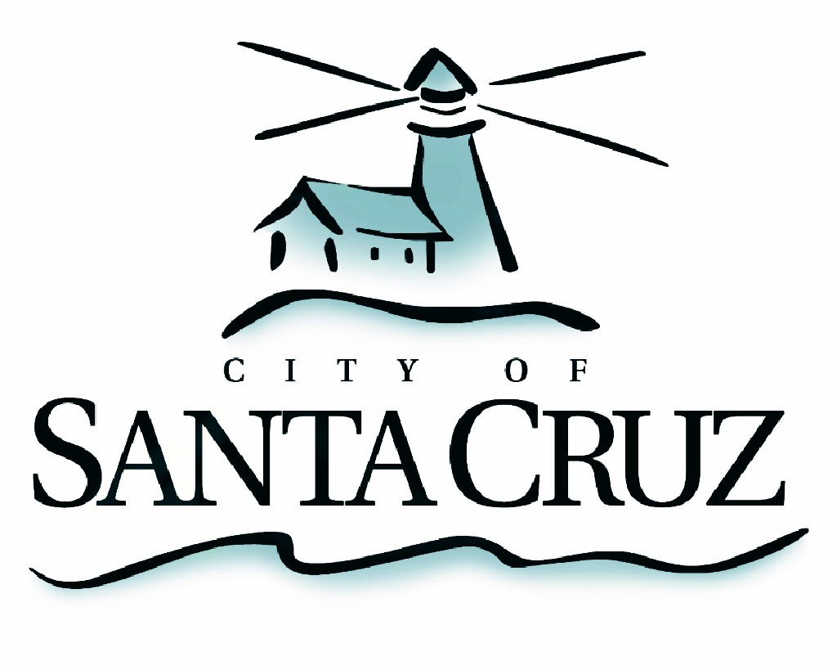

PUBLIC SAFETY COMMITTEE
REGULAR MEETING

Monday, December 17, 2012
5:30 p.m.
City Council Chambers, Santa Cruz City Hall
809 Center Street

NOTE: Four or more Councilmembers may be present at this meeting.

A G E N D A

- Call to Order

- Public Safety Committee Background

- Approval of the Minutes of the October 17, 2012 Meeting

- Public Comment on Items Not on the Agenda

- Cowell’s Beach and Surrounding Area Community Safety Discussion:
Presentations from Police, Parks and Recreation, and the City Manager Office Staff.

  - Review Existing Municipal Code Regulations and discuss Policy Recommendations for ordinance revisions to increase penalties for hypodermic needle littering; increase public safety and environmental protections at parks, beaches and public spaces:
  - Review community action based opportunities, including the model used at the San Lorenzo River Levee and permitted use of Measure E funding, and discuss recommendations to increase oversight of public spaces through expanded opportunities for volunteerism and web resources.
  - Review current partnerships with external organizations in addressing maintenance of public spaces. Discuss opportunities to address ongoing environmental, criminal and social impacts through increased coordination with local agencies.

- Communications from Committee Members (Information Only)

Adjournment -- The Public Safety Committee will adjourn from the regular meeting of December 17, 2012 to its next regular meeting, date and time to be determined.

The City of Santa Cruz does not discriminate against persons with disabilities. Out of consideration for people with chemical sensitivities, we ask that you attend fragrance free. Upon request, the agenda can be provided in a format to accommodate special needs. Additionally, if you wish to attend this public meeting and will require assistance such as an interpreter for American Sign Language, Spanish, or other special equipment, please call the City Clerk’s Department at 420-5030 at least five days in advance so that we can arrange for such special assistance. The Cal-Relay system number: 1-800-735-2922.

