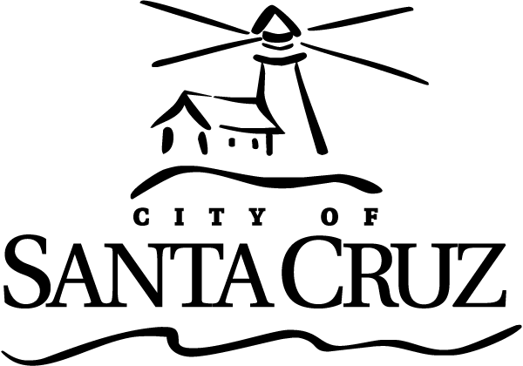 | Measure K Oversight Committee  Meeting  5:00 p.m. – Monday – October 6, 2014  City Council Chambers  809 Center Street

Call to Order

Roll Call

Oral Communications – No action may be taken

Presentations – None.

Statements of Disqualification

Announcements – No action may be taken

Approval of Minutes

Unless otherwise specified, procedures for all items are:

- Oral staff /Committee member report
- Questions from the Committee
- Public comment - 3 minutes each; maximum total time may be established by the Presiding Officer at the beginning of the item
- Committee deliberation and action

- Minutes of the April 7, 2014 Regular Meeting
Recommendation: Motion to approve the minutes of April 7, 2014.

Consent Agenda

There are no items on the Consent Agenda.

General Business

The Chair may announce and set time limits at the beginning of each agenda item. Unless otherwise specified, procedures for all items are:

- Oral staff /Committee member report
- Questions from the Committee
- Public comment - 3 minutes each; maximum total time may be established by the Presiding Officer at the beginning of the item
- Committee deliberation and action

- June 2014 Semi-Annual Report to the City Council
Recommendation: Motion to revise or accept as submitted the semi-annual report and authorize their submittal to the City Council.

Information Items – No action may be taken – None.

Items Initiated by Members for Future Agendas

Adjournment -- The Measure K Oversight Committee will adjourn from the October 6, 2014 meeting to the next scheduled meeting, date, time and location to be determined.

The City of Santa Cruz does not discriminate against persons with disabilities. Out of consideration for people with chemical sensitivities, we ask that you attend fragrance free. Upon request, the agenda can be provided in a format to accommodate special needs. Additionally, if you wish to attend this public meeting and will require assistance such as an interpreter for American Sign Language, Spanish, or other special equipment, please call the City Clerk’s Department at 420-5030 at least five days in advance so that we can arrange for such special assistance. The Cal-Relay system number: 1-800-735-2922.

The Measure K Oversight Committee was created by ordinance in 2006 to oversee the implementation of the “Lowest Law Enforcement Policy” (Santa Cruz Municipal Code Chapter 9.84), which makes investigations, citations, arrests, property seizures, and prosecutions for adult marijuana offenses on private property the lowest law enforcement priority for the City of Santa Cruz.

The Committee meets semi-annually to review marijuana citation information, to receive any grievances from individuals who believe they were subjected to law enforcement activity contrary to the Lowest Law Enforcement Priority Policy, and to submit a written report to the City Council.

The Committee invites your attendance at any of its semi-annual meetings.

