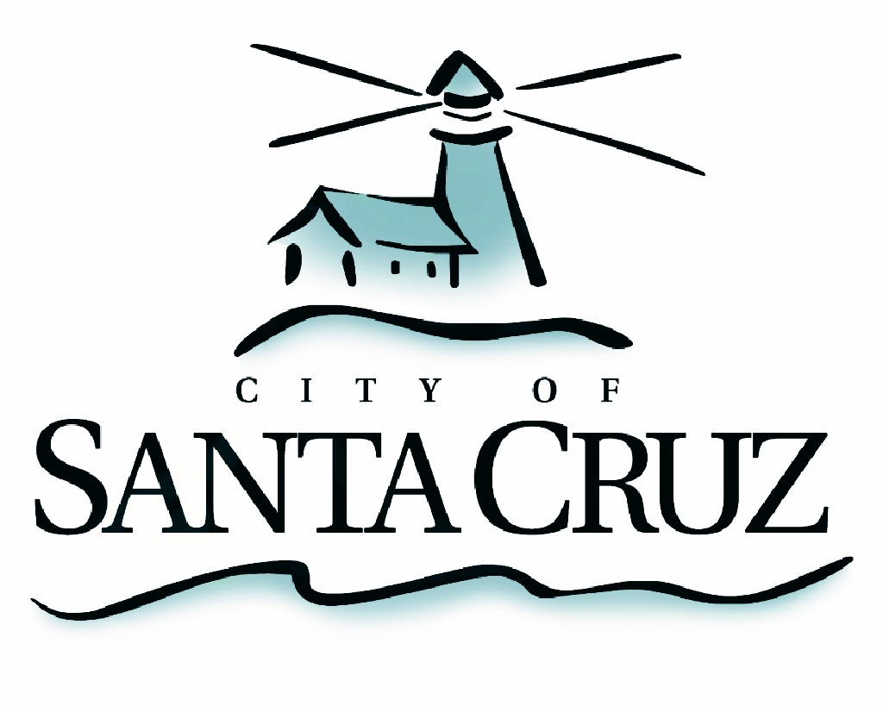

PUBLIC SAFETY COMMITTEE
REGULAR MEETING

Approved Minutes of May 1, 2013

- Chair/Councilmember Terrazas called the meeting to order at 6:07 pm in the City Council Chambers of City Hall.

Committee Members:
Present: D. Terrazas (Chair), P. Comstock, C. Mathews
Staff: Police Lt. C. McMahon, Assistant to the City Manager S. Collins
Public: Twenty members of the public

- Approval of the Minutes of the January 29, 2013 Meeting
Councilmember Mathews moved, seconded by Chair Terrazas to approve the minutes of January 29, 2013. The motion carried 3 – 0.

- Progress Report of the City Council’s Safety Action Plan, as adopted on February 12th, 2013 – Presentation from City Manager Office Staff.

Staff provided a brief overview of actions taken by the City to implement policy and programmatic direction from City Council regarding Public Safety. The Committee asked questions of staff and took no action.

- Review and Recommendations for Establishing a Remaining on Median Strips and Roundabout Ordinance for City Streets and Roads – Presentations from Police Department and City Manager Office Staff.

Staff from the City Manager’s Office and Police Department presented a draft ordinance to address the traffic safety issues around individuals remaining on median strips, traffic islands and roundabouts in the City. Staff presented evidence that traffic medians are unsafe locations for pedestrians to remain, as they create distractions for motorists and are susceptible to injury by remaining on such traffic separators. The intent of the draft ordinance is to make clear that the intended use of traffic medians, islands and roundabouts is traffic safety, and that any other use would become an infraction of the Santa Cruz Municipal Code.

Councilmember Mathews motioned to move staff’s recommendation to revise Santa Cruz Municipal Code Chapter 10.36 (regarding use of traffic medians) forward to City Council, seconded by Councilmember Comstock, with the revision to also include other traffic features such as planters, islands and other applicable traffic features. The motion carried 3-0.

- Review Committee Purpose and Goals and Establish Remaining 2013 Meeting Schedule

The Committee discussed future dates and the intent of the Public Safety Committee. No action was taken. The next meeting was scheduled

- Public Comment on Items Not on the Agenda

A few members of the public spoke about issues on Ocean Street and bike theft, and increasing reward to members of the public who provide information to the City regarding major crimes.

Adjournment – at 6:55 p.m., the Public Safety Committee adjourned from the regular meeting of May 1, 2013 to its next regularly scheduled meeting to be determined.

