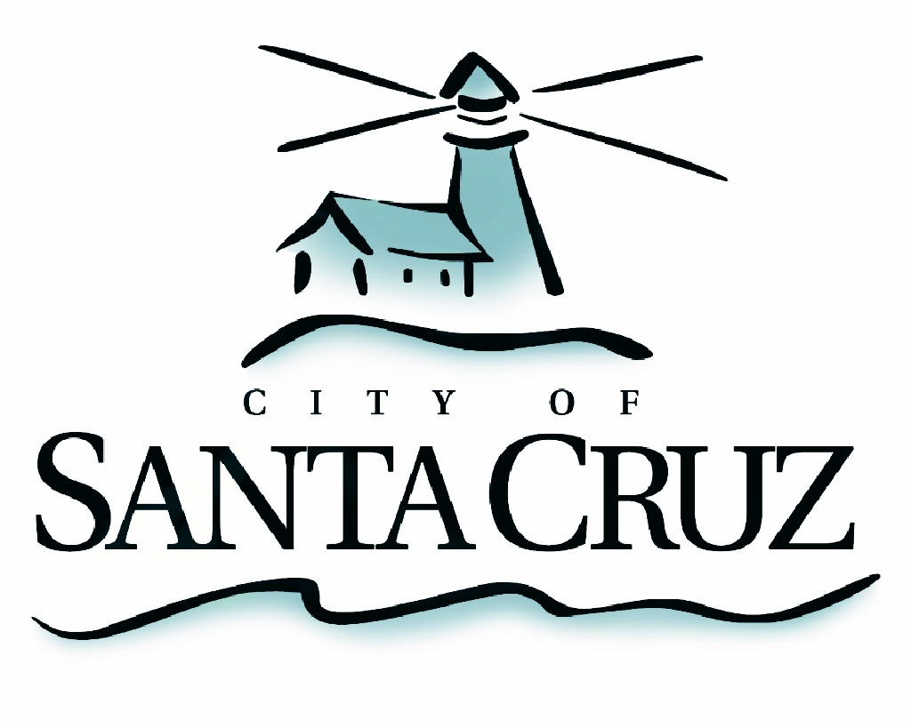

PUBLIC SAFETY COMMITTEE
REGULAR MEETING

Draft Minutes of December 17, 2012

- Chair/Councilmember Terrazas called the meeting to order at 5:32 pm in the City Council Chambers of City Hall.

Committee Members:
Present: D. Terrazas (Chair), D. Lane, L. Robinson
Staff: K. Vogel, Police Chief; D. Shoemaker, Parks and Recreation Director; S. Clark, Deputy Police Chief; R. Martinez, Deputy Police Chief; Mauro Garcia, Parks Superintendent; S. Collins, Assistant to the City Manager;
Public: Over 100 members of the public

- Public Safety Committee Background

Councilmember Terrazas provided a brief overview of the roles and responsibilities of the Public Safety Committee

- Approval of the Minutes of the October 17, 2012 Meeting

Councilmember Robinson moved, seconded by Mayor Lane, to approve the minutes of the October 17, 2012 meeting as submitted. The motion carried 3 – 0.

- Public Comment on Items Not on the Agenda

Three members of the public spoke about general public safety concerns.

- Cowell’s Beach and Surrounding Area Community Safety Discussion:
Presentations from Police, Parks and Recreation, and the City Manager Office Staff.

  - Review Existing Municipal Code Regulations and discuss Policy Recommendations for ordinance revisions to increase penalties for hypodermic needle littering; increase public safety and environmental protections at parks, beaches and public spaces:
  - Review community action based opportunities, including the model used at the San Lorenzo River Levee and permitted use of Measure E funding, and discuss recommendations to increase oversight of public spaces through expanded opportunities for volunteerism and web resources.
  - Review current partnerships with external organizations in addressing maintenance of public spaces. Discuss opportunities to address ongoing environmental, criminal and social impacts through increased coordination with local agencies.

City staff, including Police Chief Kevin Vogel, Parks and Recreation Director Dannettee Shoemaker and Assistant to the City Manager Scott Collins, as well guest presenters Santa Cruz County Sheriff Wowak, Santa Cruz County Regional Transportation Commission Executive Director George Dondero, and Save Our Shores Executive Director Laura Kasa made presentations to the Committee regarding illegal discarding of needles, community cleanliness and safety and measures that can be taken to improve community safety and responded to questions from the Committee.

Nearly 30 members of the public provided comment to the Committee about pressing public safety issues facing the community and potential solutions the City can apply to improve those conditions.

Councilmember Lane motioned, seconded by Councilmember Terrazas to direct staff to consider the following items and return to the Committee for further discussion and recommendations:
- creating a citizen-driven public safety task force,
- creating effective oversight of local hypodermic needle exchange programs and pharmacies that provide needles,
- report back on measures to achieve a fully staffed Santa Cruz Police Department, in particular police officers,
- explore placing additional restrooms, trash cans and sharps containers in public locations, and
- developing a coalition with other agencies to address the underlying public safety issues such as drug abuse in our community.

The motion carried 2 – 0. (Councilmember Robinson absent).

- Communications from Committee Members (Information Only)

No communication was shared.

Adjournment – at 9:05 p.m., the Public Safety Committee adjourned from the regular meeting of December 17, 2012 to its next regularly scheduled meeting to be determined.

