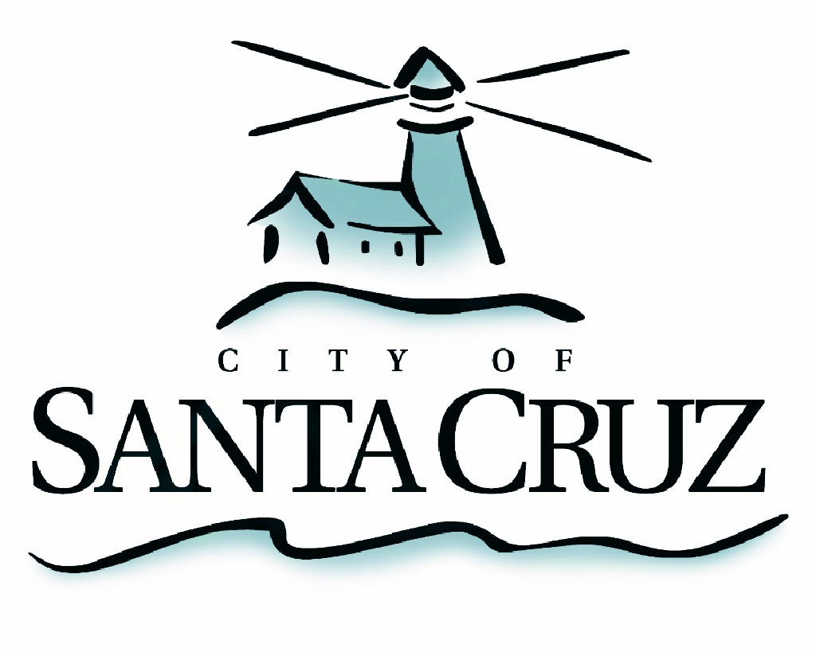

PUBLIC SAFETY COMMITTEE
REGULAR MEETING

Monday, April 20, 2015
6:00 p.m.
City Council Chambers, Santa Cruz City Hall
809 Center Street

A G E N D A

- Call to Order

- Approval of the Minutes of the June 30, 2014 Regular Meeting, and July 21, 2014 Special Closed Session Meeting

- Election of Public Safety Committee Chair and Vice Chair

- Recommendations for Amending Requirements for the Annual Traffic Safety Report (Santa Cruz Municipal Code Section 10.08.050)

- Introductory Exploration of City’s Public Safety Data Report Capabilities and Provide Staff Direction as Needed

- Public Comment on Items Not on the Agenda

- Items for Consideration in Future Meetings and Set Remaining Meeting Schedule for 2015

Adjournment -- The Public Safety Committee will adjourn from the regular meeting of April 20, 2015 to its next regular meeting, date and time to be determined.

The City of Santa Cruz does not discriminate against persons with disabilities. Out of consideration for people with chemical sensitivities, we ask that you attend fragrance free. Upon request, the agenda can be provided in a format to accommodate special needs. Additionally, if you wish to attend this public meeting and will require assistance such as an interpreter for American Sign Language, Spanish, or other special equipment, please call the City Clerk’s Department at 420-5030 at least five days in advance so that we can arrange for such special assistance. The Cal-Relay system number: 1-800-735-2922.

