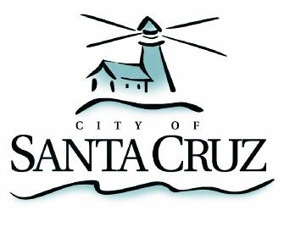

Community Programs Committee

Friday, May 22, 2015
1:00 p.m.
City Council Chambers
Santa Cruz City Hall

NOTE: Four or more Councilmembers may be present at this meeting.

A G E N D A

- Call to Order

- Public Comment on Items Not on the Agenda

- Approval of Minutes of the February 23, 2015, April 27, 2015 and May 11, 2015 Meetings.

- Follow-up on the Committee’s FY 2016-2017 Community Programs Funding Recommendations.

The Committee will finalize and forward its FY 2016-2017 funding recommendations to the City Council for consideration at the May 26, 2015 FY 2016 Budget Hearings.

- Review and Recommendations of Non-Departmental Funding Support for Safety Net Services for FY 2016.

Adjournment -- The Community Programs Committee will adjourn from the meeting of May 22, 2015 to its next meeting at a date and time to be determined.

The City of Santa Cruz does not discriminate against persons with disabilities. Out of consideration for people with chemical sensitivities, we ask that you attend fragrance free. Upon request, the agenda can be provided in a format to accommodate special needs. Additionally, if you wish to attend this public meeting and will require assistance such as an interpreter for American Sign Language, Spanish, or other special equipment, please call the City Clerk’s Department at 420-5030 at least five days in advance so that we can arrange for such special assistance. The Cal-Relay system number: 1-800-735-2922.

