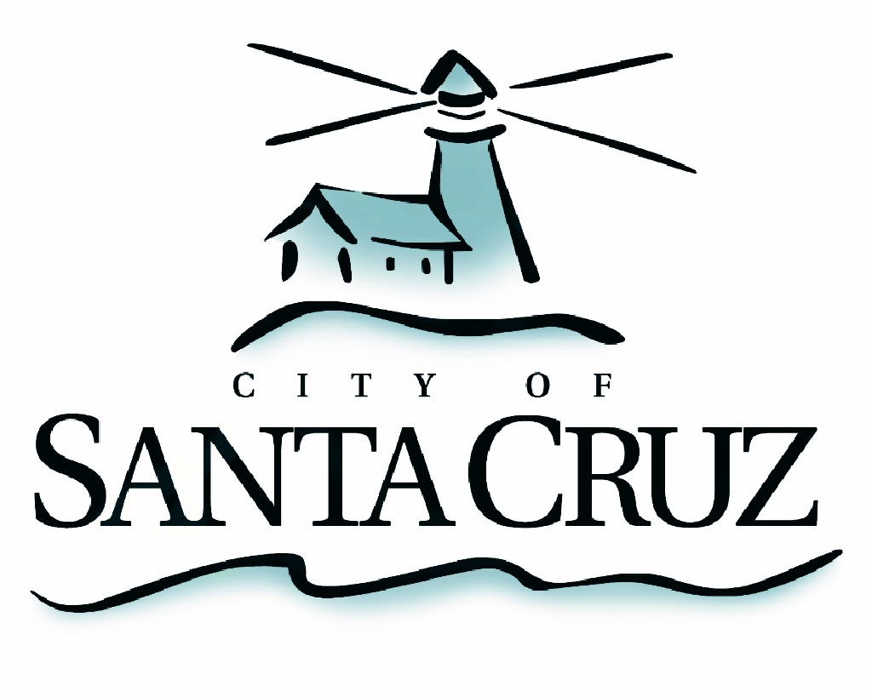

PUBLIC SAFETY COMMITTEE
SPECIAL CLOSED SESSION MEETING

Monday, August 17, 2015
4:00p.m.
City Manager’s Conference Room
Santa Cruz City Hall, 809 Center Street

SPECIAL CLOSED SESSION AGENDA
4:00 p.m., City Manager’s Conference Room

Chair Comstock will open the session in a public meeting for the purpose of announcing the agenda and taking public comment; thereafter the meeting will be closed to the public and the Committee will conduct its review. After the review, the Committee will recess the special closed session.

- Review of Police Auditor Written Evaluations and Police Files

Adjournment -- The Public Safety Committee will adjourn from the meeting of August 17, 2015 to its next meeting at a date to be determined.

The City of Santa Cruz does not discriminate against persons with disabilities. Out of consideration for people with chemical sensitivities, we ask that you attend fragrance free. Upon request, the agenda can be provided in a format to accommodate special needs. Additionally, if you wish to attend this public meeting and will require assistance such as an interpreter for American Sign Language, Spanish, or other special equipment, please call the City Clerk’s Department at 420-5030 at least five days in advance so that we can arrange for such special assistance. The Cal-Relay system number: 1-800-735-2922.

