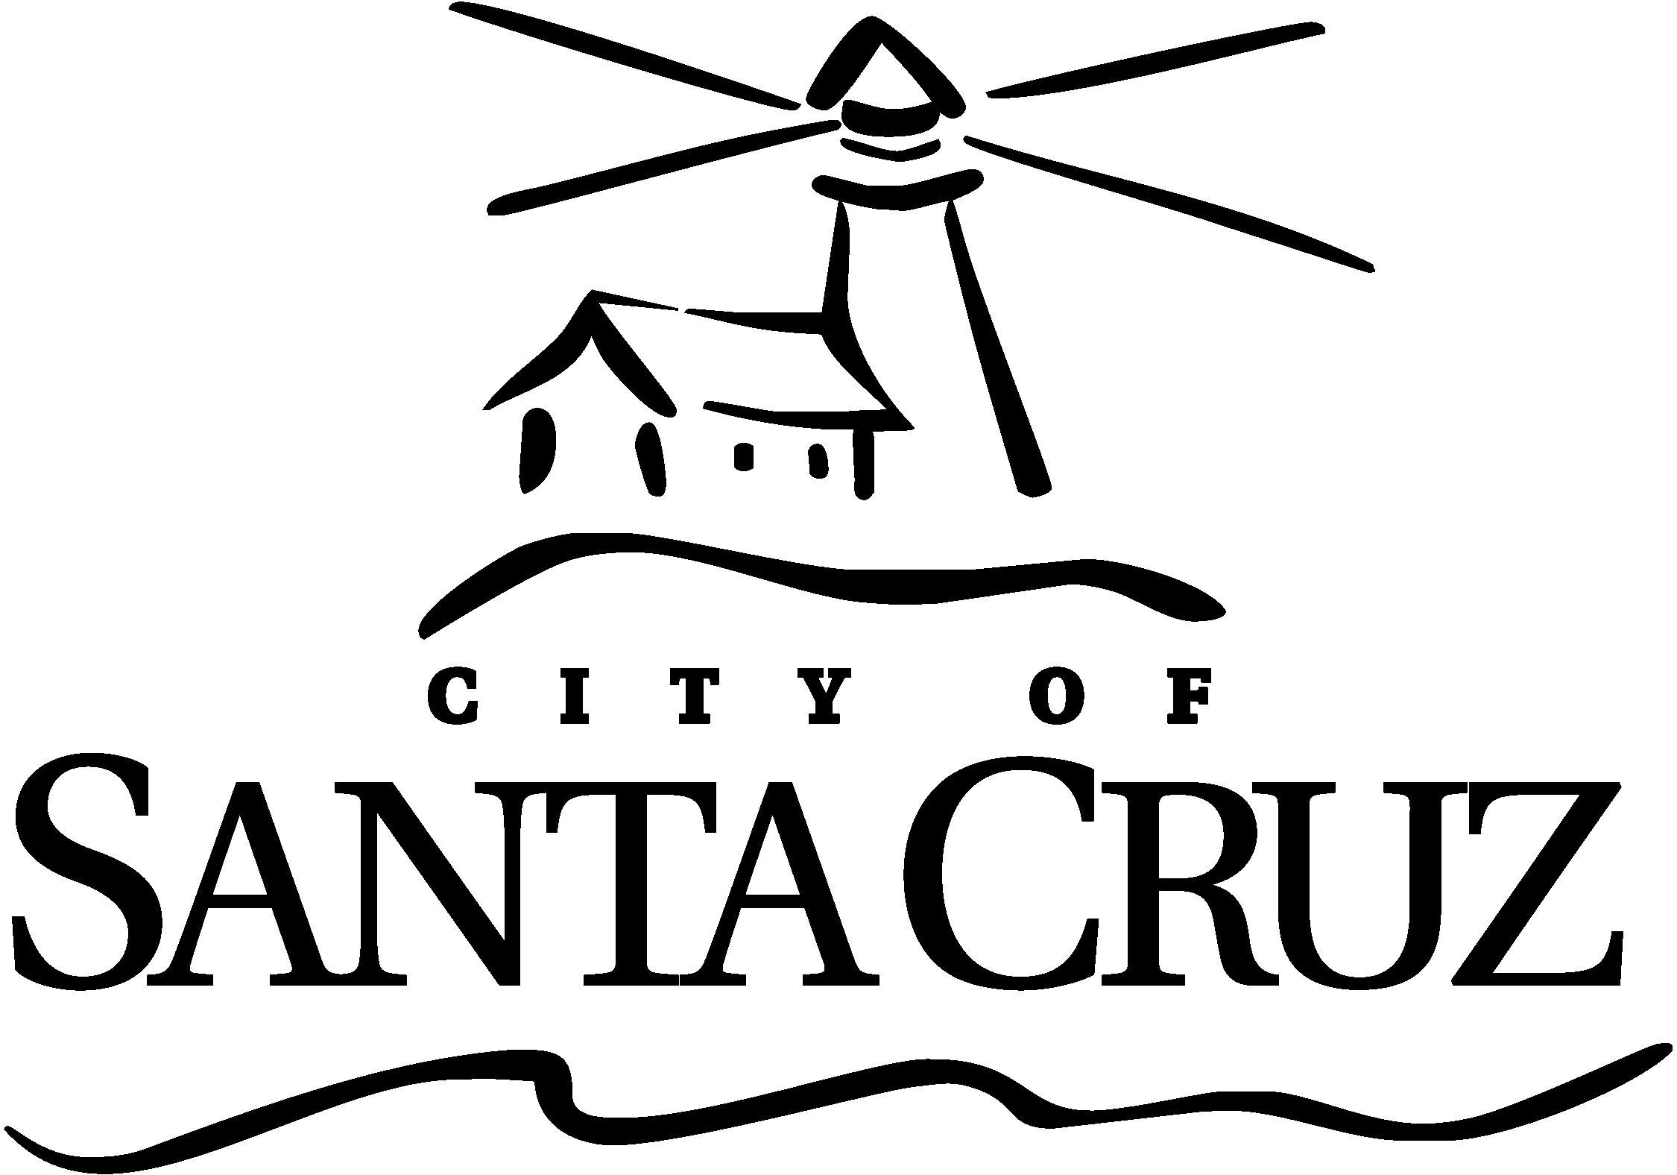

City of Santa Cruz
Strategic Plan

September 2015

DEFINITIONS:

Goals: Action that defines achievable value to the organization and community.

Strategies: Targeted direction of high level objectives that support the goal.

Key Projects: Projects and initiatives that implement the strategies and help achieve the goal.

Goal 1: Environmental Sustainability and Well-Managed Resources

Strategies:

- Preserve, protect and maintain natural resources and public space by proactively managing the City’s greenbelt, beaches, parks and waterways
- Promote environmental stewardship through the implementation of the City’s Climate Action Plan
- Ensure the availability of a safe, sustainable water supply through an integrated water quality and supply strategy

KEY PROJECTS: GOAL 1 | Related City Projects
Complete the Water Supply Advisory Committee’s work to develop and deliver to the City Council recommendations for improving the reliability of the Santa Cruz water supply. | - Various Planning and Economic Development initiatives either directly or indirectly
Complete Parks Master Plan and prioritize long-term needs including the increase of safety presence and environmental design improvements throughout the parks system, Consider establishing a Coastal Recreation Zone for long-term planning and management.
Continue efforts of the Cowells Beach Working Group to reduce the number of beach advisories due to water quality by identifying the source of contamination and deploying a plan to reduce sources of bacteria down to a naturally occurring level. | - Stormwater Program  - Beach Cleaning  - Cowell Beach Water Quality Task Force
Complete modification of flood channel between Hwy 1 and Water St. Bridge to meet requirements for the San Lorenzo River Flood Control Re-Certification.
Continue working on Endangered Species Permitting and a Habitat Conservation Plan for the San Lorenzo River and North Coast streams, including working collaboratively with other agencies and interests to support restoration of threatened and endangered fish species. | - Rivermouth Management  - HCP for Branciforte  - HCP for RRF
KEY PROJECTS: GOAL 1  Continued | Related City Projects
Develop San Lorenzo River Mouth Management Plan. | - HCP
Make Progress on Citywide bike network including Rail Trail (within City) and Branciforte Creek Bridge project. | - Active Transportation Plan
Examine potential for paddling on  the San Lorenzo River. | *At the June 23rd Council Meeting a Motion carried to accept the Lower San Lorenzo River Pilot Paddling Advisory Group report and direct the City staff to contract for a short-term baseline bird study, not to exceed $20,000 in costs, to take place in 2015 during the same timeframe as the proposed pilot program and direct the Coastal Watershed Council to pay for a pilot program to occur in 2016, which follows the paddling and wildlife conditions established by the Advisory Group recommendation.
Investigate a Parks Endowment for future needs. | - Parks and Rec Commission  - FOPAR (Friends of Parks and Recreation)  * A report will be brought to Council in August on the status of the parks endowment based on action taken by the Parks and Recreation Commission and FOPAR.

Goal 2: Community Safety & Well-Being

Strategies:

- Create an environment that fosters a feeling of personal safety, physical security and individual well-being through the continued implementation of the Public Safety Citizen Task force recommendations
- Develop and maintain ongoing coordination, partnerships and programs to focus on proactive prevention and analysis, lowering the occurrence of crime, early intervention and supervision for at-risk populations and effective rehabilitation to minimize recidivism
- Foster a community of safe, attractive and well-maintained neighborhoods and business districts through the resolution of property crimes and nuisance issues
- Support and encourage a variety of agencies that provide for the health and welfare of the community from youth to seniors
- Enhance the City’s level of disaster preparedness through improved planning, training, response, mitigation, and community outreach

KEY PROJECTS: GOAL 2 | Related City Projects
Establish proactive process which tracks and monitors recurring neighborhood safety/quality of life concerns, and triggers a coordinated response and resolution involving non-public safety staff. | - Parks Unit  - Neighborhood Enforcement Team  - Code Enforcement
Continue to invest in safety net support including City programs, community granting, and partnerships. | - PACT  - SIP  - DOW  - Homeward Bound
Focus Resources and Partnerships to reduce illegal and nuisance activity Downtown and other targeted areas. | - PACT  - SIP  - DOW  - Homeward Bound  - Parks Unit
Advance Library future planning. Including JPA governance, funding, operations, and revenue. | - Library Facilities Master Plan
KEY PROJECTS: GOAL 2  Continued | Related City Projects
Continue to invest in youth programming and support services. | - P&R Teen Programs  - Teen Intern Program  - Youth Violence Prevention Strategic Plan  - Youth Violence Prevention Working Group
Improve sanitation and illegal campsite abatement throughout the City.

Pursue options for a Public Safety Training Center and Fire Station #2 replacement. | - Fire Training JPA

Goal 3: Economic Vitality

Strategies:

- Increase tourism to the City by supporting the supply and quality of hotel stock
- Facilitate and encourage the growth and development of existing and newly emerging, high potential business sectors in our community
- Enhance the downtown, beach, wharf, and city-wide commercial corridor vibrancy by increasing the supply and variety of retail shopping options and through other activities and amenities that improve the overall visitor experience
- Provide for the development of diverse and affordable housing opportunities throughout the City
- Attract and retain a well-balanced mix of businesses that contribute to the community’s sustainability and promote the creation of quality jobs

KEY PROJECTS: GOAL 3 | Related City Projects
Facilitate and support the development of additional housing for the workforce and vulnerable populations. | - Legislative Priorities  - 2011 Affordable Housing Bond legislation underway  - Pacific Station  - Housing Element Update  - Corridor Study  - All-in Plan to end Homelessness  - Housing Study Session  - HUD  - CDBG  - Housing Element Update  - Consolidated Housing Action Plan  - ADU??
Facilitate and invest in access to dark fiber and broad band infrastructure.

Conduct Downtown parking study to analyze existing requirements, supply and demand, and make recommendations for future (infill) development. Provide Parking to Support Economic Development in the downtown area. | - Supply/ Demand Study  - Downtown Fee Structure Study
KEY PROJECTS: GOAL 3  Continued | Related City Projects
Advance the mixed-use Pacific Station project including the development of 100 units of affordable housing and public parking | - Amend the Downtown Recovery Plan and Zoning to extend height and development standards to Laurel Street.  - RiverFront/Lower Pacific Design Guidelines Study
Review and update the City’s Corridor Plan
and Zoning Ordinance for consistency with the
General Plan 2030.

Implement development review process improvements and technology tools (CRW, Open Counter) for enhanced and responsive customer service.

Implement the Wharf Master Plan. | - Wayfinding  - Miramar renovations/lease restructuring including wharf pilings financing
Create a Tannery Arts Center campus long-term sustainable management plan to address operations, maintenance and security. | - Tannery website  - CruzCal  - Arts Council contract for campus programming/ marketing  - HOA formation and meetings to address operations, maintenance and security
Explore a permanent arena/events center and pursue Civic Auditorium remodel. | - Feasibility Study
Continue partnerships with UCSC to strengthen local economic growth, innovation and opportunity | - Project for Innovation & Entrepreneurship  - PIE-MOU-student internship program  - UCSC Hackathon co-sponsor  - Center for Innovation and Entrepreneurial Development  - Santa Cruz Works
Develop and adopt an Economic Development Strategic Plan. | - ED-Strategic Plan/ED Workplan  - Budget, CIP
Implement the priority project recommendations for City-wide signage and way finding.
Goal 4: Organizational Health

Strategies:

- Foster an organization where all employees are engaged, inspired and striving for continuous improvement
- Attract, retain and develop high quality city employees
- Maintain an organizational culture of excellent customer service that builds trust, inspires confidence and promotes accountability

KEY PROJECTS: GOAL 4 | Related City Projects
Develop an organizational health plan and recommendations through the Organizational Health Committee. | - Health and Wellness Program  - Training and Development Program
Enhance internal communications to keep City staff apprised, involved, and engaged with major City actions.

Engage in employee skill development and succession planning to grow the workforce of tomorrow.

Conduct an employee satisfaction survey.

Goal 5: Financial Stability

Strategies:

- Sustains a resilient financial position supported by sustainable, balanced revenue streams, fiscally responsible expenditures and pursuit of cost-savings measures
- Explore new revenue opportunities to fund City priorities

KEY PROJECTS: GOAL 5 | Related City Projects
Evaluate citywide best practice fiscal policies including but not limited to infrastructure funding and replacement; facility and fleet replacement; future obligation funding and/or enterprise fund reserves. | - Fire Station #2 Funding
Conduct and Implement Fee Study and Establish
Fee Recovery Policy.

Evaluate new opportunities to refinance higher rate debt obligations including CalPERS unfunded liability.

Expand transient occupancy tax base to capture short-term, residential rental market(represented by websites like VRBO, AirBnB, etc.). | - Planning department evaluation/study of residential TOT impacts and possible policies

Goal 6: Reliable & Forward-Looking Infrastructure and Facilities

Strategies:

- Provide a system of safe, clean, reliable and well-maintained streets, sidewalks, bridges, parks and parking facilities
- Design, construct and proactively maintain a reliable utility infrastructure that delivers safe, clean water, controls storm water drainage and effectively manages sewage treatment
- Actively seek opportunities to leverage existing and develop new revenue sources to ensure steady support to maintain and improve the City’s infrastructure
- Strategically develop new infrastructure to meet future needs and desires of the community

KEY PROJECTS: GOAL 6 | Related City Projects
Plan for and construct Highway 1 and 9 Improvements, as well as other Harvey West area traffic safety improvements (emergency exit); and continue process for Highway 1 bridge replacement. | - Rte1- 9 improvements  - Rte 1 Bridge
Pursue a new parking structure downtown and consolidation of the surface lots to maximize land use and increase capacity including possibility of a mixed use facility. | - Downtown Parking Study Feasibility  - Economic Vitality Strategy  - Pacific Station
Plan for and prioritize current, core Water infrastructure rehabilitation and replacement projects and new infrastructure to improve supply reliability. Develop a financial plan to provide resources necessary to support implementation | - Water Supply Advisory Committee
Create a Council Revenue Subcommittee to prioritize list of outstanding infrastructure needs/desires, including deferred maintenance and explore funding sources. | - CIP Budget Review
Complete ADA assessment study of City infrastructure and facilities
KEY PROJECTS: GOAL 6  Continued | Related City Projects
Enhance City Hall Workspace to increase customer service and employee support | - Fire Station 2 Planning
Complete the Riverside Avenue Improvements including Utility and Streetscape improvements. | - Wayfinding
Develop, adopt, and implement funding for the Active Transportation Plan. | - Safe Routes to School  - SCCSCSMP

Goal 7: Engaged & Informed Community

Strategies:

- Encourage civic engagement and participation in the achievement of our goals
- Build an informed and engaged community by providing accurate and useful information about City priorities, functions and services
- Provide timely response to issues and concerns raised by community members

KEY PROJECTS: GOAL 7 | Related City Projects
Implement key elements of Communications & Community Relations Plan, including external citizen and internal employee newsletters and improved social media | - City Website Upgrade  - Citizen Survey
Update the City’s Website design to improve the end users experience and overall functionality | - Communications Plan
Implement technology solutions into the field to improve city responsiveness. | - Communications Plan
Continue to develop mechanisms that solicit regular community feedback on customer satisfaction. | - Communications Plan  - PL Counter  - P&R Master Plan Survey  - Business Council Poll

