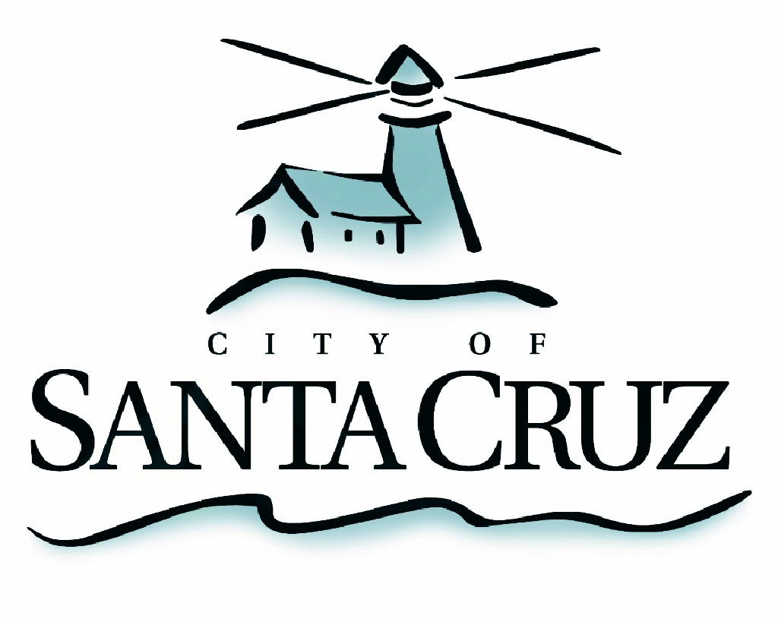

PUBLIC SAFETY COMMITTEE
REGULAR MEETING

Monday, October 5, 2015
5:00 p.m.
City Council Chambers, Santa Cruz City Hall
809 Center Street

A G E N D A

- Call to Order

- Approval of the Minutes of the April 20, 2015 Regular Meeting, and August 17, 2015 Special Closed Session Meeting

- Review City Preparation for Potential Strong El Niño Event in Winter 2015/2016

- Review Data Report Relating to Ordinance No. 2015-01, Santa Cruz Municipal Code Pertaining to Orders to Vacate Park Property

- Public Comment on Items Not on the Agenda

- Items for Consideration at Future Meetings

Adjournment -- The Public Safety Committee will adjourn from the regular meeting of October 5, 2015 to its next regular meeting, December 7, 2015.

The City of Santa Cruz does not discriminate against persons with disabilities. Out of consideration for people with chemical sensitivities, we ask that you attend fragrance free. Upon request, the agenda can be provided in a format to accommodate special needs. Additionally, if you wish to attend this public meeting and will require assistance such as an interpreter for American Sign Language, Spanish, or other special equipment, please call the City Clerk’s Department at 420-5030 at least five days in advance so that we can arrange for such special assistance. The Cal-Relay system number: 1-800-735-2922.

