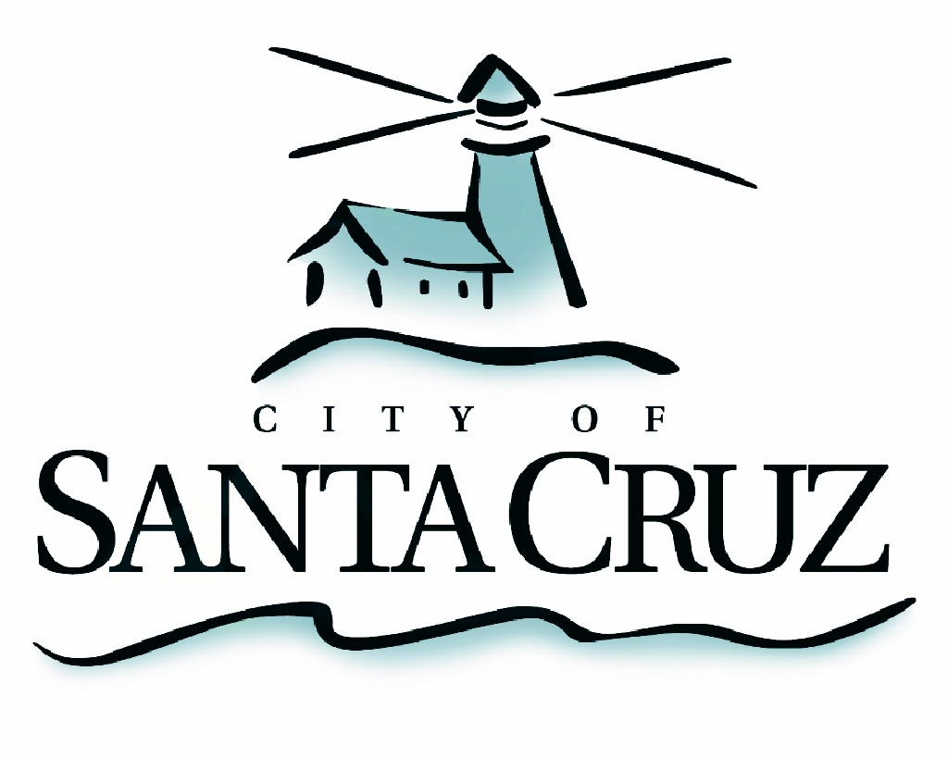

PUBLIC SAFETY COMMITTEE
REGULAR MEETING

APPROVED Minutes of April 20, 2015

- Chair/Councilmember Terrazas called the meeting to order at 6:01 pm in the City Council Chambers of City Hall.

Committee Members:
Present: D. Terrazas (Chair), P. Comstock, C. Chase
Staff: Assistant to the City Manager S. Collins, Deputy Police Chief R. Martinez
Public: Five members of the public

- Approval of the Minutes of the June 30, 2014 Regular Meeting, and July 21, 2014 Special Closed Session Meeting
Councilmember Comstock moved, seconded by Chair Terrazas to approve the minutes of June 30, 2014 and July 21, 2014. The motion carried 2 – 0, with Councilmember Chase abstaining as she was not present at either of those meetings.

- Election of Public Safety Committee Chair and Vice Chair
Councilmember Chase moved, seconded by Councilmember Terrazas to appoint Councilmember Comstock as Public Safety Committee Chair for 2015. The motion
carried 3 – 0.

- Recommendations for Amending Requirements for the Annual Traffic Safety Report (Santa Cruz Municipal Code Section 10.08.050)

Staff provided a brief overview of the type of reporting that is currently available to the public regarding traffic safety. Committeemmebers asked staff several questions regarding options to enhance annual reporting to City Council on this issue.

Motion by Councilmember Terrazas to present a draft annual traffic safety report to the Public Works/Transportation Commission by first quarter of Calendar Year 2016, as outlined in Santa Cruz Municipal Code section 10.08.050, for review and recommendation to the full council. The draft report should include pertinent data with geographic based information related to safe routes to schools, parks, cultural centers, and other significant public destinations as well as neighborhood safety data The report will be brought forward to City Council in the first quarter of FY 2016 and each year to follow, in order to provide timely information in preparation for the annual CIP process and to monitor safety improvements as a result of investment in new infrastructure and safety programs, second by Councilmember Comstock. Motion passes 3-0.

- Introductory Exploration of City’s Public Safety Data Report Capabilities and Provide Staff Direction as Needed

Staff presented the Committee with an overview of the types of public safety data that is collected and reported by the City.

Motion by Councilmember Terrazas for staff to bring back an inventory of public safety reporting and sample data reports from other agencies with recommendations to prepare an annual public safety report/s. Report/s may include map based reporting of calls for service, nuisance properties and other pertinent safety issues, needs to initiate data collection for future reporting and monitoring as well as recommendations for what resources are required to provide this data and reporting which may include implementation of new technology. Second by Councilmember Chase. Motion passes 3-0.

- Public Comment on Items Not on the Agenda

No comments were received from the public.

- Items for Consideration in Future Meetings and Set Remaining Meeting Schedule for 2015

The Committee discussed the desire to learn more about Recreational/Oversized vehicles (RVs), bike theft, City and County joint funded programs, among other items to learn more about in the future.

Adjournment – at 7:10 p.m., the Public Safety Committee adjourned from the regular meeting of April 20, 2015 to its next regularly scheduled meeting to be determined.

