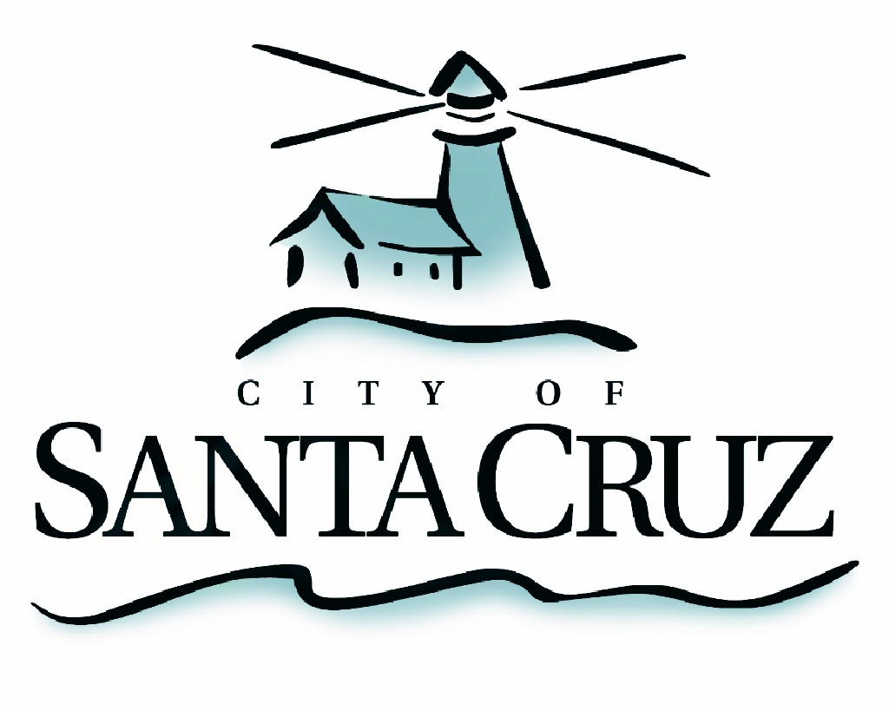

PUBLIC SAFETY COMMITTEE
SPECIAL CLOSED SESSION MEETING

APPROVEDminutes of Monday, August 17, 2015

At 4:21 p.m., Chair Comstock opened the session in a public meeting for the purpose of announcing the agenda and taking public comment. No public comment was offered and at 4:22 p.m. Chair Comstock closed the open portion of the meeting.

I. Review of Police Auditor Written Evaluations and Police Files

Committee Members:
Present: P. Comstock (Chair); D. Terrazas’ C. Mathews
Staff: B. Aaronson, Internal Police Auditor; S. Clark, Deputy Police Chief; R. Martinez, Deputy Police Chief; J. Hernandez (Rank); M. Bernal, City Manager

The Public Safety Committee reviewed the Independent Police Auditor written evaluation and the corresponding police files. No action was taken.

Adjournment – At 6:35 p.m., Chair Comstock recessed the special closed session meeting of August 17, 2015 to the next scheduled regular meeting.

The City of Santa Cruz does not discriminate against persons with disabilities. Out of consideration for people with chemical sensitivities, we ask that you attend fragrance free. Upon request, the agenda can be provided in a format to accommodate special needs. Additionally, if you wish to attend this public meeting and will require assistance such as an interpreter for American Sign Language, Spanish, or other special equipment, please call the City Clerk’s Department at 420-5030 at least five days in advance so that we can arrange for such special assistance. The Cal-Relay system number: 1-800-735-2922.

