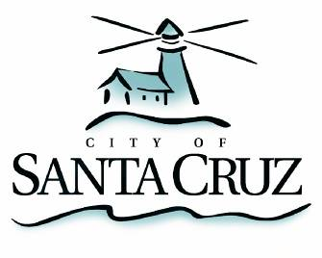

#### Community Programs Committee

Friday, June 17, 2016

**5:00 p.m.**

City Council Chambers

Santa Cruz City Hall

**NOTE: Four or more Councilmembers may be present at this meeting.**

### A G E N D A

1. Call to Order
2. Public Comment on Items Not on the Agenda
3. Receive Staff Update on the Community Programs Grant Funding Process Review and Provide Direction as Appropriate

**Adjournment** -- The Community Programs Committee will adjourn from the meeting of June 17, 2016 to its next meeting at a date and time to be determined.

*The City of Santa Cruz does not discriminate against persons with disabilities. Out of consideration for people with chemical sensitivities, we ask that you attend fragrance free. Upon request, the agenda can be provided in a format to accommodate special needs. Additionally, if you wish to attend this public meeting and will require assistance such as an interpreter for American Sign Language, Spanish, or other special equipment, please call the City Clerk’s Department at 420-5030 at least five days in advance so that we can arrange for such special assistance. The Cal-Relay system number: 1-800-735-2922.*