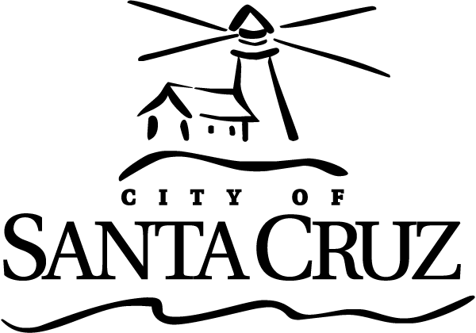 | Commission for the Prevention of Violence Against Women  POLICE COMMITTEE Meeting  AGENDA  Wednesday, November 16, 2016 5:30 p.m.  City Manager’s Conference Room (Room 10)  809 Center Street Santa Cruz CA 95060

Call to Order: Commissioners Greenburg, Tobisch, Thurman, Police Liaison, CPVAW staff

Roll Call:

Statements of Disqualification:

Minutes: Minutes of November 18, 2015 meeting are available for review and can be approved by motion.

Oral Communications: Public comment on items not on the agenda (Note: No action may be taken on these items):

General Business: Chair may set time limit on agenda items.
- Appointment of Committee Chair
- Status of reports received from the SCPD
- CPVAW Sexual Assault Data Entry

Items for Future Agenda

Adjournment to Confidential Session: May adjourn to review redacted cases.
Confidential Session: (Closed to public; Committee members review & discuss confidential reports or issues)
The CPVAW Police Subcommittee will adjourn to a Confidential Session to review sexual assault redacted reports and spreadsheets.
Adjournment to closed session pursuant to, and in accordance with, California Government Code Section 54957 to review redacted police reports.

Items from Confidential Session Initiated by Members for Future Agenda:

Adjournment from Confidential Session
The CPVAW Police Committee meeting of March 16, 2016 will adjourn to the next meeting to be scheduled at a date/time/location to be determined.

CPVAW contact: Scott Collins 831-420-5017/scollins@cityofsantacruz.com or cpvaw@cityofsantacruz.com

