CITY OF SANTA CRUZ  809 Center Street  Santa Cruz, California 95060 | 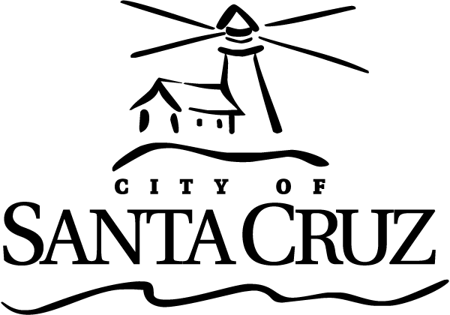

COMMISSION FOR THE PREVENTION OF VIOLENCE AGAINST WOMEN (CPVAW)
Regular Meeting

September 07, 2016

6:45 p.m. | General Business and Matters of Public Interest, Council Chambers
Written material for every item listed on the agenda is available for review at the City Manager’s office, 809 Center Street, Room 10, and online at www.cityofsantacruz.com.

Time limits set by Commission Policy are guidelines. Unless otherwise specified, procedures for all items, are:
- Oral staff report
- Public comment - 3 minutes each; maximum total time may be established by the Presiding Officer at the beginning of an agenda item
- Commission deliberation and action

No action will be taken on items listed under Presentations, Oral Communications, Announcements, Information Items and Committee Reports

Appeals - Any person who believes that a final action of this advisory body has been taken in error, that decision may or may not be appealable to the City Council. Appeals must be in writing, setting forth the nature of the action and the basis upon which the action is considered to be in error, and addressed to the City Council in care of the City Clerk. Appeals must be received by the City Clerk within ten (10) calendar days following the date of the action from which such appeal is being taken. An appeal must be accompanied by a fifty dollar ($50) filing fee.

Additional Information
Visit the City’s Web Site at www.cityofsantacruz.com with links including City Advisory Body Meeting Agendas and Minutes, Advisory Body Information, and the Santa Cruz Municipal Code.
A copy of the full CPVAW agenda, agenda reports and attachments which are included in the meeting packet, is available for review at the Central Library on Church Street no later than three (3) days prior to the meeting date.
The City of Santa Cruz does not discriminate against persons with disabilities. Out of consideration for people with chemical sensitivities, we ask that you attend fragrance free. If you wish to attend this public meeting and will require assistance, such as an interpreter for American Sign Language, Spanish, or other special equipment, please call the CPVAW at (831) 420-5363 or e-mail cpvaw@cityofsantacruz.com at least five (5) days in advance so that arrangements for such assistance can be accommodated. The Cal-Relay system number: 1-800-735-2922.
Any writing related to an agenda item for the open session of this meeting distributed to the CPVAW less than 72 hours before this meeting is available for inspection at the CPVAW Office at 809 Center Street, Room 10. These writings will also be available for review at the CPVAW meeting in the Council Chambers.
Commission for the Prevention of Violence Against Women (CPVAW) - 831-420-5363 - cpvaw@cityofsantacruz.com.

Commission for the Prevention of Violence Against Women (CPVAW)

6:45 PM

Call to Order

Roll Call

Voting Members: Commissioners Fullum-Campbell, Guzman, Newman, Thurman, and Tobisch; Vice Chair Queen; Chair Greenburg

Absent with Notification: None

Other Members: Teen Representatives Risa Mykland

Staff: Santa Cruz Police Liaison Escalante; Scott Collins, Deputy City Manager and Commission Coordinator

Presentations: None

Statements of Disqualifications

Oral Communications

Announcements

- Announcements by Chair
- Other Commission Member Announcements
- Teen Representatives
- Staff Announcements

Approval of Minutes

1 | Minutes of August 3, 2016

Approve, by motion, the minutes from the regular meeting of August 3, 2016 as submitted.

General Business

2 | Domestic Violence (DV) Awareness Month activities for October 2016

That the Commission for the Prevention of Violence Against Women review 2016 DV Awareness Month activities, and, by motion, take action as needed.

General Business (continued)

3 | Contracts for CPVAW Services and Grants

That the Commission discuss implementation of a new contract system (for its vendors and grantees) that is comparable to the standards and best practices established and used by the City of Santa Cruz Finance Department, and by motion, take action as necessary.

4 | Commission for the Prevention of Violence Against Women (CPVAW) Annual Report 2014-15

That the Commission review and edit the Draft Annual Report 2014 2015 content, and provide direction as appropriate.

Information Items

Reports from Ad Hoc and Standing Committees

AD HOC COMMITTEES:
- Engaging the Bystander (Queen, Tobisch, and new Commissioner)
- Teen Dating Violence Awareness Month (Newman and Teen Representative)
- Domestic Violence Awareness Month (Newman, Queen, and Fullum-Campbell)
- Annual Report (Newman and Tobisch)
STANDING COMMITTEE:
- Police Committee: Next meeting: TBD

Items Initiated by Members for Future Agendas

Adjournment

