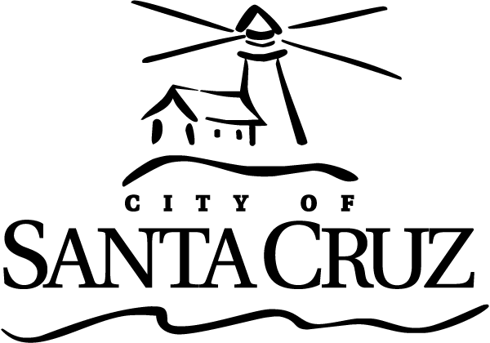 | Commission for the Prevention of Violence Against Women (CPVAW)  Special Meeting for CPVAW Retreat  December 2, 2015  5:30 p.m.–9:30 p.m. (estimated end time)  Courtyard Conference Room  809 Center Street, Santa Cruz  MINUTES  Minutes were approved as submitted at the February 3, 2016 meeting.

This special meeting is for discussing future CPVAW goals and work plan. Commissioners may take action and/or provide direction to staff and/or other members on any item, as warranted by the discussion.

There will be no oral communications at this meeting. Members of the public have the right to speak on any item on the agenda at the time designated.

Call to Order – Welcome by Chair

Chair Greenburg welcomed attendees.
Present: Chair Greenburg; Vice Chair Queen; Commissioners Tobisch, Newman, Thurman, and Fullum-Campbell (one vacancy)
City Staff: Shull, Collins, Schmidt, Agnone

- Review of Agenda, Guidelines, and Goals for Retreat
Retreat Goals:
- Step back, reflect, and outline ongoing and recurring work
- Discuss new or uncompleted projects
- Prioritize work plan for 2016

- Public Comment on Items on the Agenda (3 minutes per speaker)
None

- Review the CPVAW’s Ongoing and Recurring Work and Prioritize Projects for 2016 (Led by Laura Schmidt, IT Director)
City IT Director Schmidt facilitated a comprehensive discussion of the CPVAW’s goals, required efforts, discretionary activities, events, and trainings. Through that discussion, the CPVAW developed a Draft 2016 Work Plan. In developing the work plan, CPVAW members assigned themselves to eight (8) total ad hoc committees, with committee titles and membership reflected below:

  - Police Report Review (Greenburg, Tobisch, and Thurman)
  - Engaging the Bystander (Queen, Tobisch, and new Commissioner)
  - Homeless Women and Transgender Safety (Greenburg, Queen, and Fullum-Campbell)
  - Sexual Assault Awareness Month (Thurman, Newman, and Fullum-Campbell)
  - One Billion Rising (Thurman and Queen)
  - Teen Dating Violence Awareness Month (Newman and Teen Representative)
  - Domestic Violence Awareness Month (Newman, Queen, and Fullum-Campbell)
  - Annual Report (Newman and Tobisch)
- Update from City Manager’s Office of City Manager’s Resources (Directed by Tina Shull, Assistant City Manager, and Scott Collins, Assistant to the City Manager)
Tina Shull, Assistant City Manager, and Scott Collins, Assistant to the City Manager, provided an overview of the current status of the City Manager’s Office. The City Manager’s Office is conducting a review of its operations and expects to come up with a plan to reallocate resources according to greatest priority areas. In developing this plan, the City Manager’s Office will likely be able to designate a permanent position in the office to help manage the CPVAW at approximately ten (10) hours per week. The Commissioners discussed potential impacts to the CPVAW work plan, particularly that the diminished staff hours assigned to the CPVAW would erode its potential to deliver on its goals. Staff responded that with a new matrix approach to doing the work (Commissioners, staff, and partners) this should not negatively impact the work of the CPVAW. Staff will provide an update to the CPVAW once it is clearer in terms of staffing direction (hopefully resolved by the end of FY 2016 – June 2016).

Adjournment
The Commission for the Prevention of Violence Against Women adjourned at 9:26 p.m. from the Special Retreat Meeting of December 2, 2015 to the next regular meeting scheduled for Wednesday, February 3, 2016 at 6:45 p.m. in the City Council Chambers, 809 Center Street, Santa Cruz.

Additional Information
Visit the City’s Web Site at www.cityofsantacruz.com with links to the Commission for the Prevention of Violence Against Women, including City Advisory Body Meeting Agendas and Minutes, Advisory Body Information, and the Santa Cruz Municipal Code.

The City of Santa Cruz does not discriminate against persons with disabilities. Out of consideration for people with chemical sensitivities, we ask that you attend fragrance free. If you wish to attend this public meeting and will require assistance, such as an interpreter for American Sign Language, Spanish, or other special equipment, please e-mail the Commission for the Prevention of Violence Against Women at cpvaw@cityofsantacruz.com or call (831) 420-5363 at least three (3) days in advance so that arrangements can be made for such assistance. The Cal-Relay system number: 1-800-735-2922.

