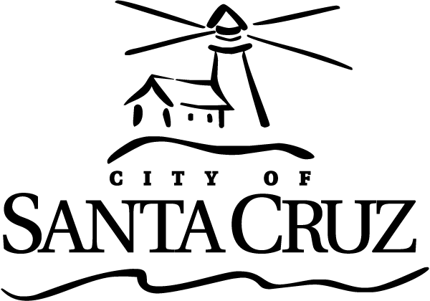 | Commission for the Prevention of Violence Against Women (CPVAW)  Regular Meeting  MINUTES  Wednesday, March 2, 2016  6:45 p.m.  Council Chambers, 809 Center Street/Santa Cruz  Minutes were approved as submitted at the May 4, 2016 meeting.

Call to Order: Chair Greenburg called the meeting to order at 6:48 p.m.

Roll Call: Voting Members: Chair Greenburg; Commissioners Guzman, Newman, Thurman, and Tobisch
Absent with Notification: Queen, Fullum-Campbell
Other Members: None present
Staff: Santa Cruz Police Liaison Escalante; Scott Collins, Assistant to the City Manager and Acting CPVAW Staff

Presentation: None

Statements of Disqualification: None

Oral Communications: None

Announcements – (No action may be taken.)
- Announcements by Chair Greenburg: Academy Award show highlighted sexual assault and story on This America Life discussed rape; Greenburg and Tobisch attended the highly successful trans conference hosted at the Coconut Grove.
- Announcement by Commissioner Newman: First addition of the CPVAW newsletter sent out.

Approval of Minutes

- Minutes of February 3, 2016
RECOMMENDATION: Approve, by motion, the minutes from the regular meeting of
February 3, 2016 as submitted.

MOTION: Commissioner Tobisch made a motion, seconded by Commissioner Thurman, to approve the minutes of February 3, 2016 as submitted.

ACTION: The motion carried with the following vote.
AYES: Tobisch, Greenburg, Newman, Guzman, and Thurman
NOES: None
ABSENT: Queen, Fullum-Campbell
DISQUALIFIED: None

General Business

- CPVAW Request for Proposals for Funding
RECOMMENDATION: That CPVAW members review recommendations from the Homeless Women and Transgender Safety Ad Hoc Committee regarding grant applications for FY 2016 CPVAW funding, and, by motion, take action as necessary.
MOTION: Commissioner Thurman made a motion, seconded by Commissioner Newman, to approve funding of $1,500 for the Diversity Center, $1,500 for Positive Discipline Community Resources, and $500 for UCSC in FY 2016 to support their programs that contribute to the goals of the Commission.

ACTION: The motion carried with the following vote.
AYES: Tobisch, Newman, Guzman, and Thurman
NOES: Greenburg
ABSENT: Queen, Fullum-Campbell
DISQUALIFIED: None

- Proposed Camping Ordinance Amendment
RECOMMENDATION: That CPVAW members review, discuss, and, by motion, take action to request that the City Council support the amendments to Section 6.36 of the Santa Cruz Municipal Code (Camping) to remove reference to the act of sleeping and possibly the use of blankets and sleeping bags as violations of the ordinance.

MOTION: Commissioner Newman made a motion, seconded by Commissioner Guzman, to direct the CPVAW Chair to send a letter to the City Council requesting that it support the proposed amendments to Section 6.36 of the Santa Cruz Municipal Code (Camping) to remove reference to the act of sleeping and possibly the use of blankets and sleeping bags as violations of the ordinance.

ACTION: The motion carried with the following vote.
AYES: Tobisch, Greenburg, Newman, and Guzman
NOES: Thurman
ABSENT: Queen, Fullum-Campbell
DISQUALIFIED: None

- Fiscal Year 2017 Proposed Budget Review for CPVAW
RECOMMENDATION: That CPVAW members review the proposed budget for the CPVAW for FY 2017, and, by motion, take action as necessary.

No action was taken.

Information Items – None

Committee Reports

Commissioners provided status updates on the following efforts:

AD HOC COMMITTEES:
- Police Report Review – Ad-hoc group will meet on March 16.
- Engaging the Bystander – Ad-hoc group has yet to meet.
- Homeless Women and Transgender Safety – Ad-hoc group began work in January 2016, will sunset in July 2016.
- Sexual Assault Awareness Month – Scott will coordinate with the ad-hoc group.
- One Billion Rising – Event to be held on March 12.
- Teen Dating Violence Awareness Month – Focus on improving coordination for 2017.
- Domestic Violence Awareness Month – Ad-hoc group has not yet met.
- Annual Report – Ad-hoc group will begin its work in April or May.

STANDING COMMITTEE
Police Committee: Next meeting: Wednesday, March 16, 2016 at 5:30 p.m. in the City Manager’s Conference Room/809 Center, Room 10/Santa Cruz, CA 95060.

Items Initiated by Members for Future Agendas

Adjournment
The Commission for the Prevention of Violence Against Women adjourned from the regular meeting of Wednesday, March 2, 2016 at 8:09 p.m. to the next scheduled CPVAW meeting of Wednesday,
May 4, 2016 at 6:45 p.m. in the Santa Cruz City Council Chambers/809 Center Street/Santa Cruz, CA 95060.

Appeals
Any person who believes that a final action of this advisory body has been taken in error, that decision may or may not be appealable to the City Council. Appeals must be in writing, setting forth the nature of the action and the basis upon which the action is considered to be in error, and addressed to the City Council in care of the City Clerk. Appeals must be received by the City Clerk within ten (10) calendar days following the date of the action from which such appeal is being taken. An appeal must be accompanied by a fifty dollar ($50) filing fee.

Additional Information
Visit the City’s Web Site at www.cityofsantacruz.com with links including City Advisory Body Meeting Agendas and Minutes, Advisory Body Information, and the Santa Cruz Municipal Code.

A copy of the full CPVAW agenda, agenda reports and attachments which are included in the meeting packet, is available for review at the Central Library on Church Street no later than three (3) days prior to the meeting date.

The City of Santa Cruz does not discriminate against persons with disabilities. Out of consideration for people with chemical sensitivities, we ask that you attend fragrance free. If you wish to attend this public meeting and will require assistance, such as an interpreter for American Sign Language, Spanish, or other special equipment, please call the CPVAW at (831) 420-5363 or e-mail cpvaw@cityofsantacruz.com at least five (5) days in advance so that arrangements for such assistance can be accommodated. The Cal-Relay system number: 1-800-735-2922.

Any writing related to an agenda item for the open session of this meeting distributed to the CPVAW less than 72 hours before this meeting is available for inspection at the CPVAW Office at 809 Center Street, Room 10. These writings will also be available for review at the CPVAW meeting in the Council Chambers.

Commission for the Prevention of Violence Against Women (CPVAW)
831-420-5363
cpvaw@cityofsantacruz.com

