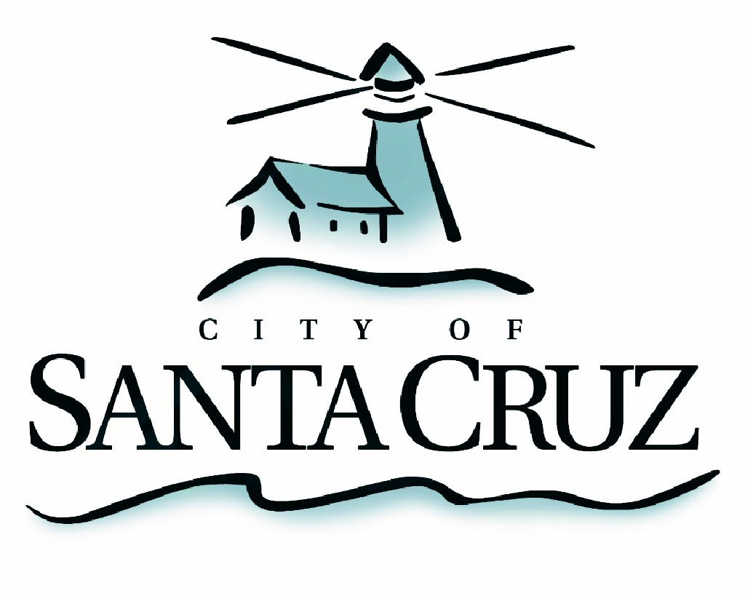

PUBLIC SAFETY COMMITTEE
REGULAR MEETING

Draft Minutes of December 7, 2015

- Chair/Councilmember Comstock called the meeting to order at 5:01 pm in the City Council Chambers of City Hall.

Committee Members: P. Comstock (Chair), C. Chase, D. Terrazas
Staff: City Manager M. Bernal, Assistant to the City Manager S. Collins, Principal Management Analyst, S. O’Hara, Police Chief K. Vogel, Deputy Police Chief R. Martinez, Deputy Police Chief S. Clark, Principal Management Analyst L. Alamos
Public: No public audience

- Approval of the Minutes of the October 5, 2015 Regular Meeting

Councilmember Chase moved, seconded by Chair Comstock to approve the minutes of October 5, 2016. The motion carried 2 – 0 with Councilmember Terrazas abstaining because he was not in attendance for the October 5th, 2015 meeting.

- Receive Presentation from Santa Cruz Police Department on Bike Theft Data and Action Plan

Principal Management Analyst Alamos presented and answered councilmember questions on the topic.

- Discussion Regarding Neighborhood Policing Projects, Public Safety Reporting and Recommendations

Councilmembers and staff engaged in a discussion on this topic.

- Public Comment on Items Not on the Agenda

No comments were received from the public.

- Items for Consideration at Future Meetings

No items were added to future agendas.

Adjournment – at 6:30 p.m., the Public Safety Committee adjourned from the regular meeting of December 7, 2015.

The City of Santa Cruz does not discriminate against persons with disabilities. Out of consideration for people with chemical sensitivities, we ask that you attend fragrance free. Upon request, the agenda can be provided in a format to accommodate special needs. Additionally, if you wish to attend this public meeting and will require assistance such as an interpreter for American Sign Language, Spanish, or other special equipment, please call the City Clerk’s Department at 420-5030 at least five days in advance so that we can arrange for such special assistance. The Cal-Relay system number: 1-800-735-2922.

