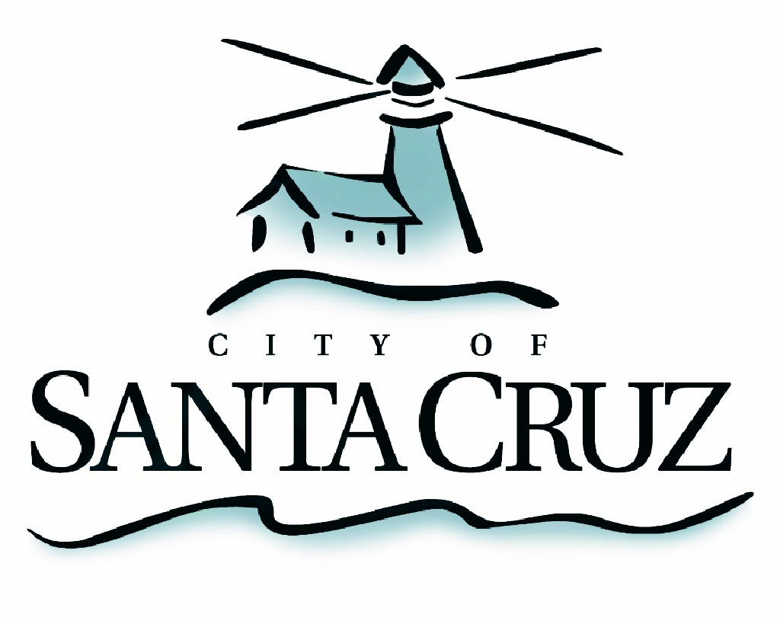

PUBLIC SAFETY COMMITTEE
REGULAR MEETING

APPROVED Minutes of March 29, 2016

- Chair/Councilmember Comstock called the meeting to order at 5:01 pm in the City Council Chambers of City Hall.

Committee Members:
Present: P. Comstock (Chair), D. Terrazas C. Chase
Staff: Assistant to the City Manager S. Collins, Police Chief K. Vogel, Deputy Police Chief S. Clark, Deputy Police Chief R. Martinez, Principal Management Analyst S. O’Hara, Police Principal Management Analyst L. Alamos, Community Relations Specialist J. Blaschke
Public: Two members of the public

- Approval of the Minutes of the December 7, 2015 Regular Meeting
Councilmember Comstock moved, seconded by Councilmember Chase to approve the minutes of December 7, 2015. The motion carried 2 – 0, with Councilmember Terrazas abstaining as he was not present at the December 7, 2015 meeting.

- Election of Public Safety Committee Chair and Vice Chair
Councilmember Chase moved, seconded by Councilmember Terrazas to appoint Councilmember Comstock as Public Safety Committee Chair for 2016. The motion
carried 3 – 0.

- Receive Presentation from Santa Cruz Police Department on the Annual Review of Crime Statistics

Police Principal Management Analyst L. Alamos presented an overview of crime statistics for the City of Santa Cruz for the calendar year of 2015. Committeemembers asked questions about the report and discussed options to enhance reporting for future years. No action was taken.

- Discussion Regarding 3-1-1/Constituent Management System

Staff presented a brief overview of plans to provide an online application to the public to report issues to the City. Committeemembers asked questions about the City’s plans to make this application available and when to expect such a system to go live. Staff responded that the item will go before City Council as part of the FY 2017 Budget discussion. No action was taken.

- Review City Manager’s Office Staff Presentation and Provide Feedback on the 2016 Committee Work Plan, Recurring Agenda and Meeting Schedule

Principal Management Analyst S. O’Hara presented the Committee with a framework to review the City’s overall efforts to provide a safe community. Topics included staff providing regular updates to the Committee on the Neighborhood Safety Team, Coordinated efforts with the County, outreach to state and federal partners for assistance and other items. Committeemembers asked questions and asserted their support for providing such a framework. They further requested that staff provide additional background on the Public Safety Committee history at a future meeting date and options to provide additional data to support recommendations to the City Council. No action was taken.

- Public Comment on Items Not on the Agenda

One member of the public spoke about safety conditions on Ocean Street.

- Items for Consideration at Future Meetings

No discussion.

Adjournment – at 7:25 p.m., the Public Safety Committee adjourned from the regular meeting of March 29, 2016 to its next regularly scheduled meeting to be determined.

