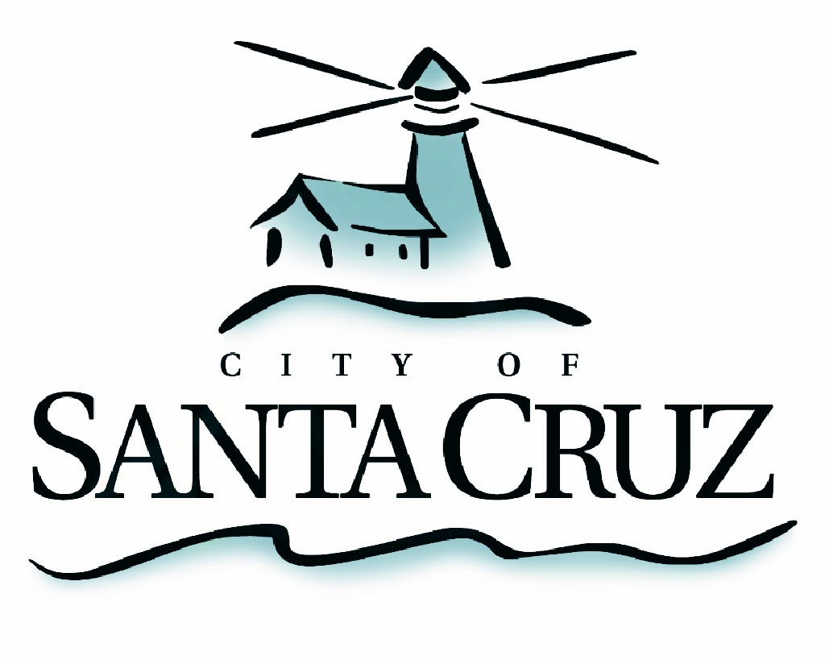

PUBLIC SAFETY COMMITTEE
SPECIAL CLOSED SESSION MEETING

APPROVED minutes of Monday, August 22, 2016

At 5:01 p.m., Chair Comstock opened the session in a public meeting for the purpose of announcing the agenda and taking public comment. No public comment was offered related to the closed session agenda, and at 5:12 p.m. Chair Comstock closed the open portion of the meeting.

I. Review of Police Auditor Written Evaluations and Police Files

Committee Members:
Present: P. Comstock (Chair); D. Terrazas; C. Chase
Staff: B. Aaronson, Internal Police Auditor; S. Clark, Deputy Police Chief; R. Martinez, Deputy Police Chief; J. Garcia, Police Sergeant; T. Shull, Assistant City Manager

The Public Safety Committee reviewed the Independent Police Auditor written evaluation and the corresponding police files. No action was taken.

Adjournment – At 7:35 p.m., Chair Comstock recessed the special closed session meeting of August 22, 2016 to the next scheduled regular meeting.

The City of Santa Cruz does not discriminate against persons with disabilities. Out of consideration for people with chemical sensitivities, we ask that you attend fragrance free. Upon request, the agenda can be provided in a format to accommodate special needs. Additionally, if you wish to attend this public meeting and will require assistance such as an interpreter for American Sign Language, Spanish, or other special equipment, please call the City Clerk’s Department at 420-5030 at least five days in advance so that we can arrange for such special assistance. The Cal-Relay system number: 1-800-735-2922.

