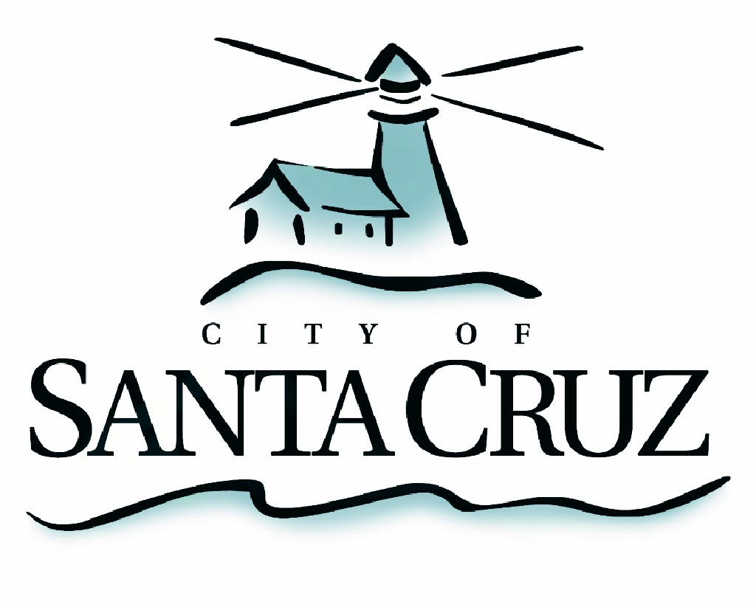

PUBLIC SAFETY COMMITTEE
REGULAR MEETING

Monday, October 24, 2016
5:00 p.m.
City Council Chambers, Santa Cruz City Hall
809 Center Street

A G E N D A

- Call to Order

- Approval of the Minutes of the September 26, 2016 Regular Meeting

- Discussion and Recommendations Regarding Environmental Design, Safety, Maintenance and Activation Efforts on the Riverwalk

- Public Comment on Items Not on the Agenda

- Items for Consideration at Future Meetings

Adjournment -- The Public Safety Committee will adjourn from the regular meeting of October 24, 2016 to its next regular meeting to be determined.

The City of Santa Cruz does not discriminate against persons with disabilities. Out of consideration for people with chemical sensitivities, we ask that you attend fragrance free. Upon request, the agenda can be provided in a format to accommodate special needs. Additionally, if you wish to attend this public meeting and will require assistance such as an interpreter for American Sign Language, Spanish, or other special equipment, please call the City Clerk’s Department at 420-5030 at least five days in advance so that we can arrange for such special assistance. The Cal-Relay system number: 1-800-735-2922.

