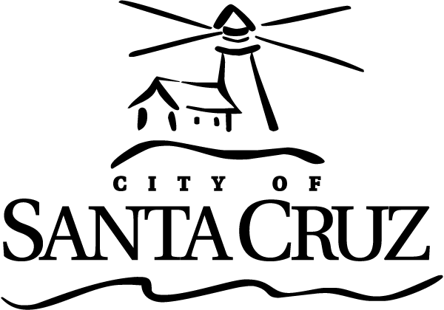 | Approved Minutes  Measure K Oversight Committee  Meeting  6:00 p.m. – Monday – October 28, 2013  City Council Chambers  809 Center Street

Call to Order Scott Collins, Assistant to the City Manager, Called the meeting to order 6:02 PM in City Council Chambers

Roll Call Measure K Oversight Committee Members:

Present: Members Dann, Attlesey, Hull, Teigen, and Elston.

Absent: None.

Staff: S. Collins

Oral Communications – None.

Presentations – None.

Statements of Disqualification – None.
Announcements – None.
Approval of Minutes

- Minutes of April 29, 2013 Regular Meeting

Member Dann moved, seconded by Member Hull to approve the minutes of April 29, 2013. The motion carried unanimously.

Consent Agenda - There were no items on the Consent Agenda.

General Business

- June 2013 Semi-Annual Reports to the City Council
Staff S. Collins provided an overview of the report. The Committee discussed the report.

Member Dann moved, seconded by Member Teigen, to approve the Semi-Annual Report. The motion carried unanimously.

Information Items – None.

Items Initiated by Members for Future Agendas – none.

Adjournment -- The Measure K Oversight Committee adjourned at 6:15 p.m. from the October 28, 2013 meeting to the next scheduled meeting, date and time uncertain.

