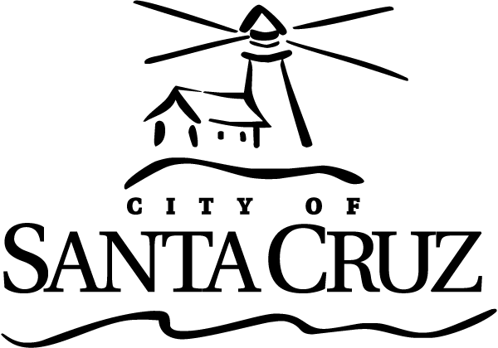 | Approved Minutes  Measure K Oversight Committee  Meeting  6:00 p.m. – Monday – April 7, 2014  City Council Chambers  809 Center Street

Call to Order Scott Collins, Assistant to the City Manager, Called the meeting to order at 5:32 PM in City Council Chambers

Roll Call Measure K Oversight Committee Members:

Present: Members Dann, Singleton, Hull, Teigen, Elston and Brune.

Absent: Member Attlesey

Staff: S. Collins

Oral Communications – None.

Presentations – None.

Statements of Disqualification – None.
Announcements – None.
Approval of Minutes

- Minutes of October 28, 2013 Regular Meeting

Member Dann moved, seconded by Member Hull to approve the minutes of April 29, 2013. The motion carried 4 – 0 (Attlesey was absent and Brune and Singleton did not participate in the October 28, 2013 meeting).

Consent Agenda - There were no items on the Consent Agenda.

General Business

- December 2014 Semi-Annual Reports to the City Council
Staff S. Collins provided an overview of the report. The Committee discussed the report.

Member Dann moved, seconded by Member Teigen, to approve the Semi-Annual Report. The motion carried unanimously (Attlesey was absent).

Information Items – None.

Items Initiated by Members for Future Agendas – none.

Adjournment -- The Measure K Oversight Committee adjourned at 5:45 p.m. from the April 7, 2014 meeting to the next scheduled meeting, date and time uncertain.

