CITY OF SANTA CRUZ  809 Center Street  Santa Cruz, California 95060 | 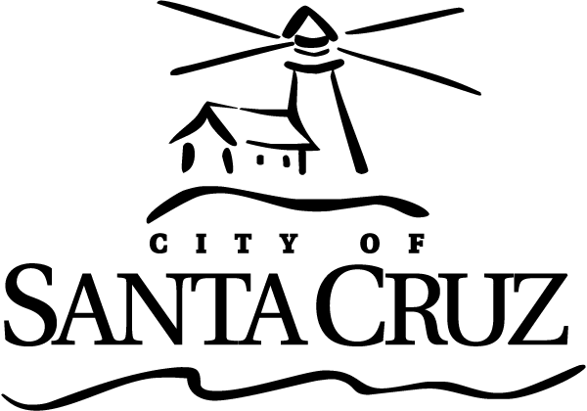

COMMISSION FOR THE PREVENTION OF VIOLENCE AGAINST WOMEN (CPVAW)
Regular Meeting

March 01, 2017

6:45 p.m. | General Business and Matters of Public Interest, Council Chambers
Written material for every item listed on the agenda is available for review at the City Manager’s office, 809 Center Street, Room 10, and online at www.cityofsantacruz.com.

Time limits set by Commission Policy are guidelines. Unless otherwise specified, procedures for all items, are:
- Oral staff report
- Public comment - 3 minutes each; maximum total time may be established by the Presiding Officer at the beginning of an agenda item
- Commission deliberation and action

No action will be taken on items listed under Presentations, Oral Communications, Announcements, Information Items and Committee Reports

Appeals - Any person who believes that a final action of this advisory body has been taken in error, that decision may or may not be appealable to the City Council. Appeals must be in writing, setting forth the nature of the action and the basis upon which the action is considered to be in error, and addressed to the City Council in care of the City Clerk. Appeals must be received by the City Clerk within ten (10) calendar days following the date of the action from which such appeal is being taken. An appeal must be accompanied by a fifty dollar ($50) filing fee.

Additional Information
Visit the City’s Web Site at www.cityofsantacruz.com with links including City Advisory Body Meeting Agendas and Minutes, Advisory Body Information, and the Santa Cruz Municipal Code.
A copy of the full CPVAW agenda, agenda reports and attachments which are included in the meeting packet, is available for review at the Central Library on Church Street no later than three (3) days prior to the meeting date.
The City of Santa Cruz does not discriminate against persons with disabilities. Out of consideration for people with chemical sensitivities, we ask that you attend fragrance free. If you wish to attend this public meeting and will require assistance, such as an interpreter for American Sign Language, Spanish, or other special equipment, please call the CPVAW at (831) 420-5363 or e-mail cpvaw@cityofsantacruz.com at least five (5) days in advance so that arrangements for such assistance can be accommodated. The Cal-Relay system number: 1-800-735-2922.
Any writing related to an agenda item for the open session of this meeting distributed to the CPVAW less than 72 hours before this meeting is available for inspection at the CPVAW Office at 809 Center Street, Room 10. These writings will also be available for review at the CPVAW meeting in the Council Chambers.
Commission for the Prevention of Violence Against Women (CPVAW) - 831-420-5363 - cpvaw@cityofsantacruz.com.

Commission for the Prevention of Violence Against Women (CPVAW)

6:45 PM

Call to Order

Roll Call

Voting Members: Commissioners Fullum-Campbell, Grossman, Guzman (vacancy), Newman, Thurman, Tobisch; Chair Greenburg

Absent with Notification: None

Staff: Santa Cruz Police Liaison Escalante; Scott Collins, Deputy City Manager and Commission Coordinator

Presentations: None

Statements of Disqualifications

Oral Communications

Announcements

- Announcements by Chair
- Other Commission Member Announcements
- Teen Representatives
- Staff Announcements

Approval of Minutes

1. | Minutes of November 2, 2016

Approve, by motion, the Minutes from the regular meeting of November 2, 2016 as submitted.

General Business

2. | Election of Chair and Vice Chair and CPVAW Police Standing Committee Assignments for 2017

That the Commission for the Prevention of Violence Against Women (CPVAW) members elect a Chair and Vice Chair for the 2017 calendar year and confirm assignments to standing committee, and, by motion, take action as necessary.

General Business (continued)

3. | Sexual Assault Awareness Month – April 2017

That the Commission for the Prevention of Violence Against Women (CPVAW) members review the draft flyer to plan activities and partnerships for April 2017 as Sexual Assault Awareness Month, and, by motion, take action as necessary.

4. | Walk A Mile In Her Shoes Event – Friday, April 28, 2017

That the Commission for the Prevention of Violence Against Women (CPVAW) members receive information regarding the event sponsored by Monarch Services of Santa Cruz County to determine level of partnership, support, and participation, and, by motion, take action as necessary.

5. | Santa Cruz Trauma Consortium Membership

That the Commission for the Prevention of Violence Against Women approve by motion the $50 annual membership fee to the Santa Cruz Trauma Consortium.

6. | Letter to the US Congress with Regard to the Potential Defunding of the Violence Against Women Act

That the Commission for the Prevention of Violence Against Women discuss the drafting of and by motion, take action to write a letter on behalf of CPVAW and the Santa Cruz City Council to our representatives in the US Congress urging them to prevent cuts to the funding of the Violence Against Women Act (VAWA).

7. | Fiscal Year 2017 Budget Review for CPVAW

That the Commission for the Prevention of Violence Against Women (CPVAW) members review the CPVAW FY 2017 Budget, and, by motion, take action as necessary.

General Business (continued)

8. | 2017 Retreat Planning

That the Commission for the Prevention of Violence Against Women (CPVAW) members establish a Retreat meeting date and time and meeting agenda, and provide direction as necessary.

Information Items

Reports from Ad Hoc and Standing Committees

AD HOC COMMITTEES:
- Engaging the Bystander (Newman, Tobisch, and new Commissioner)
- Annual Report (Newman and Tobisch)
- Safety Skills and Self-Defense Class Contracts Review (Newman, Guzman, and Greenberg)

STANDING COMMITTEE:
- Police Committee: Next Meeting: TBD

Items Initiated by Members for Future Agendas

Adjournment

