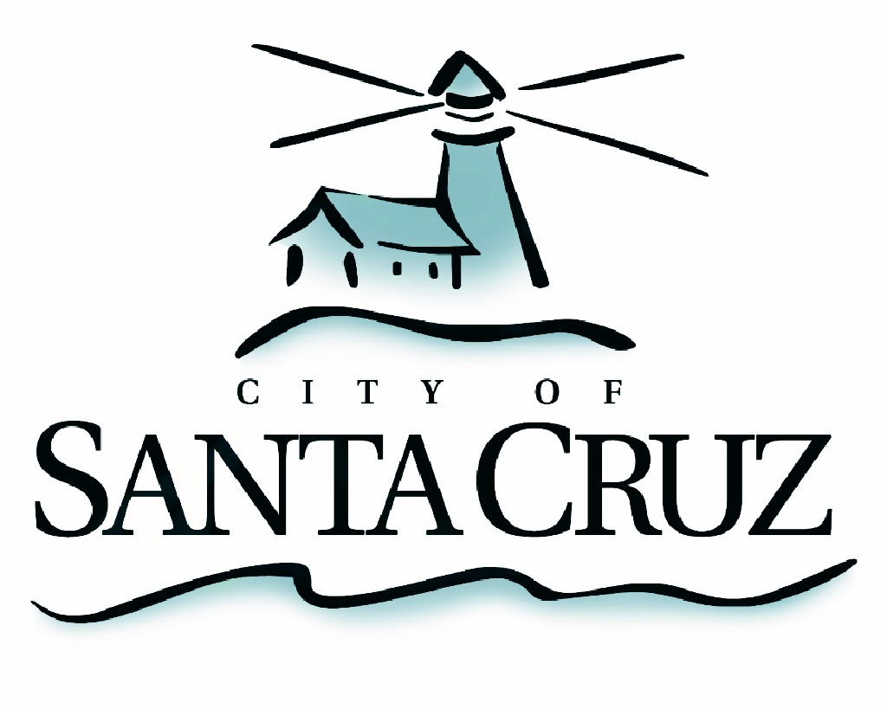

PUBLIC SAFETY COMMITTEE
REGULAR MEETING

Monday, April 17, 2017
5:00 p.m.
City Council Chambers, Santa Cruz City Hall
809 Center Street

A G E N D A

- Call to Order

- Approval of the Minutes of the February 6, 2017 Regular Meeting

- Neighborhood Safety Team Update

- Police Data Report Review

- Consider Proposed Parks Safety Enhancement Zones Ordinance Revision and Provide Recommendations

- Public Comment on Items Not on the Agenda

Adjournment -- The Public Safety Committee will adjourn from the regular meeting of April 17, 2017 to its next regular meeting to be determined.

The City of Santa Cruz does not discriminate against persons with disabilities. Out of consideration for people with chemical sensitivities, we ask that you attend fragrance free. Upon request, the agenda can be provided in a format to accommodate special needs. Additionally, if you wish to attend this public meeting and will require assistance such as an interpreter for American Sign Language, Spanish, or other special equipment, please call the City Clerk’s Department at 420-5030 at least five days in advance so that we can arrange for such special assistance. The Cal-Relay system number: 1-800-735-2922.

