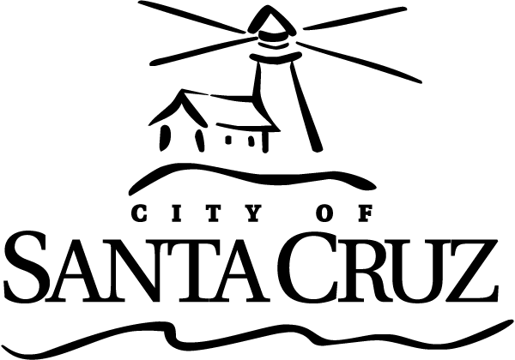 | Commission for the Prevention of Violence Against Women  AGENDA  SPECIAL RETREAT MEETING  Tuesday, April 18, 2017  5:00 p.m.–9:00 p.m. (estimated end time)  City Hall Courtyard Conference Room  809 Center Street, Room 2/Santa Cruz

This Special Retreat Meeting is scheduled to consider past work and discuss future goals and work plan for the Commission for the Prevention of Violence (CPVAW). No action is being recommended at this meeting. Commissioners may provide direction to staff and/or Commissioners on items as warranted by the discussion. Items that will require action will be brought back on a future agenda for general discussion and time for public comment before final action is taken.

Members of the public are welcome to attend.

There will be no oral communications, presentations, statements of disqualifications, announcements, approval of minutes, or committee reports at this meeting.

This meeting will not be audio recorded.

Note: As part of this working meeting, dinner will be provided for Commission members and staff.

Call to Order and Roll Call: Commission Members: Chair Newman and Commissioners Tobisch, Greenburg, Thurman, Guzman, Grossman and Fullum-Campbell; Teen Representative Risa Mykland; Staff: Deputy City Manager Collins, Principal Management Analyst O’Hara and Police Lieutenant Escalante; Retreat Facilitator Merrill and Wolf.

Welcome and Introductions

Review of Agenda, Guidelines, and Goals for Retreat
RETREAT GOALS:
- Step back, reflect, and outline ongoing and recurring work
- Discuss new or uncompleted projects
- Prioritize strategies and work plan for 2017

Public Comment – A time for members of the public to speak for 3 minutes to items on the agenda.

Review the CPVAW’s 2016 Accomplishments
Review events, programs, and projects that are routinely completed each year and Commissioner orientation requirements – Facilitator Merrill and Wolf

CPVAW Goals and Action Plan Prioritization
Review new or uncompleted Commission projects, events, and other pertinent items; develop strategies and prioritized draft work plan for 2017 – Facilitator Merrill and Wolf

Items Initiated by Members for Future Agendas

Adjournment
The CPVAW will adjourn from the Special Retreat meeting of Tuesday, April 18, 2017 to the next regularly scheduled meeting to be determined.

Appeals
Any person who believes that a final action of this advisory body has been taken in error that decision may or may not be appealable to the City Council. Appeals must be in writing, setting forth the nature of the action and the basis upon which the action is considered to be in error, and addressed to the City Council in care of the City Clerk. Appeals must be received by the City Clerk within ten (10) calendar days following the date of the action from which such appeal is being taken. An appeal must be accompanied by a fifty dollar ($50) filing fee.

Additional Information
Visit the City’s Web Site at www.cityofsantacruz.com for links to advisory bodies, including City Advisory Body Meeting Agendas and Minutes, advisory body information, and the Santa Cruz Municipal Code.

A copy of the full CPVAW agenda, agenda reports and attachments which are included in the meeting packet, is available for review at the Central Library on Church Street no later than three (3) days prior to the meeting date.

The City of Santa Cruz does not discriminate against persons with disabilities. Out of consideration for people with chemical sensitivities, we ask that you attend fragrance free. If you wish to attend this public meeting and will require assistance, such as an interpreter for American Sign Language, Spanish, or other special equipment, please call the CPVAW at (831) 420-5363 or e-mail cpvaw@cityofsantacruz.com at least two (2) days in advance so that arrangements for such assistance can be accommodated. The Cal-Relay system number: 1-800-735-2922.

Any writing related to an agenda item for the open session of this meeting distributed to the CPVAW less than 72 hours before this meeting is available for inspection at the CPVAW Office at 809 Center Street, Room 10. These writings will also be available for review at the CPVAW meeting in the Council Chambers.

Commission for the Prevention of Violence Against Women
(831) 420-5363  cpvaw@cityofsantacruz.com  Staff: Scott Collins, Deputy City Manager

