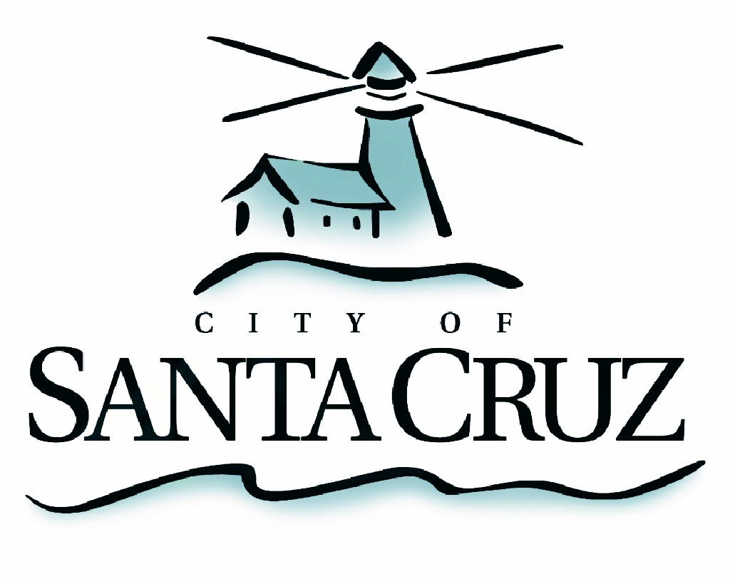

PUBLIC SAFETY COMMITTEE
REGULAR MEETING

APPROVED Minutes of September 26, 2016

- Chair/Councilmember Comstock called the meeting to order at 5:01 pm in the City Council Chambers of City Hall.

Committee Members:
Present: P. Comstock (Chair), D. Terrazas, C. Chase
Staff: City Manager M. Bernal, Parks and Recreation Director M. Garcia, Deputy City Manager S. Collins, Deputy Police Chief R. Martinez, Principal Management Analyst S. O’Hara
Public: Four members of the public

- Approval of the Minutes of the March 29, 2016 Regular Meeting, and August 22, 2016 Special Closed Session Meeting

Councilmember Terrazas moved, seconded by Vice Mayor Chase to approve the minutes of March 29, 2016 and August 22, 2016. The motion carried 3 – 0.

- Progress Update on the Neighborhood Safety Team

Staff provided a brief overview of the efforts underway by the Neighborhood Safety Team and next areas of consideration. Committeemembers asked staff several questions regarding the Team.

No action taken.

- Discussion and Recommendations Regarding Environmental Design, Safety, Maintenance and Activation Efforts on the Riverwalk

Staff presented the Committee with an overview of the efforts underway to improve public safety conditions on the Riverwalk and presented options to sustain improvements through investment in one-time infrastructure projects, on-going staffing increases and engagement activities. Committeemembers discussed and asked several questions about infrastructure projects, including if they could be scaled up or down, how to avoid duplication of efforts with partnering agencies and potential timelines to bring the issues to City Council for consideration and approval.

Motion by Councilmember Terrazas for the Neighborhood Safety Team to develop and bring back to the Committee no later than October 24, 2106 a formal and comprehensive Riverwalk Safety proposal, with a prioritized listing of options, budget and timeline. Further, staff is directed to work with community partners in developing the Riverwalk Engagement proposal. Second by Councilmember Chase. Motion passes 3-0.

- Public Comment on Items Not on the Agenda

One member of the public made comments.

- Items for Consideration in Future Meetings

The Committee discussed the desire to learn more about public safety data related to parks and libraries and receive an update on the PACT program.

Adjournment – at 6:21 p.m., the Public Safety Committee adjourned from the regular meeting of September 26, 2016 to its next regularly scheduled meeting to be determined.

