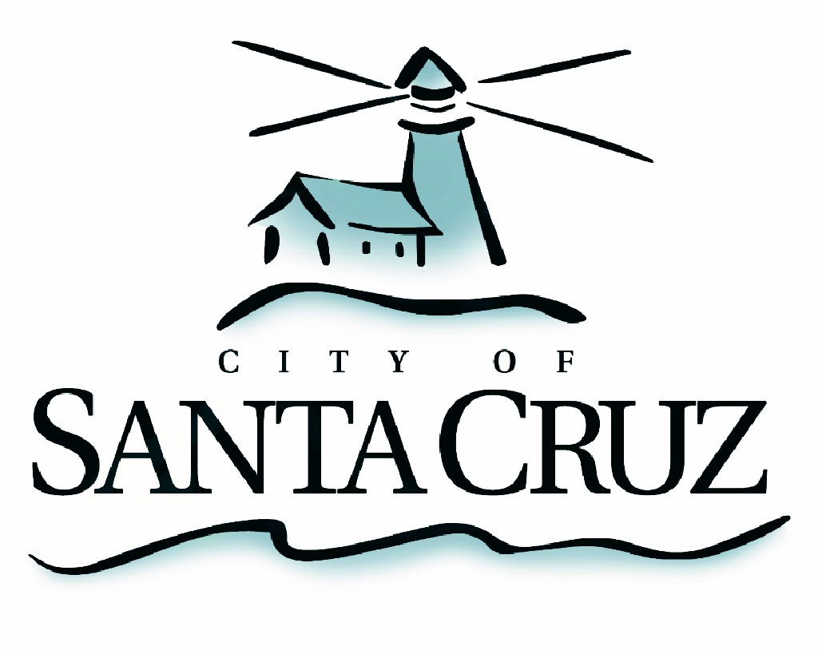 | Transportation and Public Works Commission  Regular Meeting Agenda  7:00 p.m. – Monday – June 17, 2019  City Council Chambers  809 Center Street

The regularly scheduled meeting of
Monday, June 17, 2019
of the Transportation and Public Works
Commission has been
CANCELLED

Cancellations are decided jointly by the department and the Commission Chair as needed from time to time.
The next regularly scheduled meeting is scheduled for
August 19, 2019
At 7:00 p.m. in City Council Chambers

