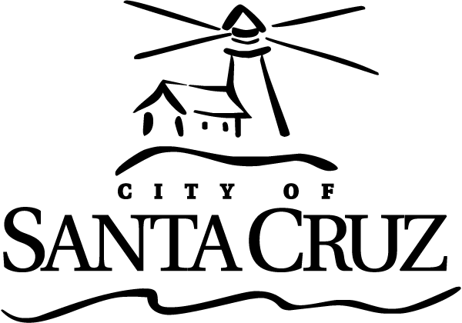 | CITY OF SANTA CRUZ  809 Center Street  Santa Cruz, California 95060

DOWNTOWN COMMISSION (DTC)
Regular Meeting

September 26, 2019

8:30 A.M. | General Business and Matters of Public Interest, Council Chambers
Commission meetings are audio recorded and will be posted to the Advisory Body webpage following the meeting.

Written material for every item listed on the agenda is available for review at the Public Works office, 809 Center Street, Room 201, and online at www.cityofsantacruz.com.

Time limits set by Commission Policy are guidelines. Unless otherwise specified, procedures for all items, are:
- Oral staff report
- Public comment - 3 minutes each; maximum total time may be established by the Presiding Officer at the beginning of an agenda item
- Commission deliberation and action

No action will be taken on items listed under Oral Communications, Announcements, Presentations, and Information Items

Appeals - Any person who believes that a final action of this advisory body has been taken in error, that decision may or may not be appealable to the City Council. Appeals must be in writing, setting forth the nature of the action and the basis upon which the action is considered to be in error, and addressed to the City Council in care of the City Clerk Administrator. Appeals must be received by the City Clerk Administrator within ten (10) calendar days following the date of the action from which such appeal is being taken. An appeal must be accompanied by a fifty dollar ($50) filing fee.

Additional Information
Visit the City’s Web Site at www.cityofsantacruz.com with links including City Advisory Body Meeting Agendas and Minutes, Advisory Body Information, and the Santa Cruz Municipal Code.
A copy of the full DTC agenda, agenda reports and attachments which are included in the meeting packet, are available for review at the Central Library on Church Street no later than three (3) days prior to the meeting date.
The City of Santa Cruz does not discriminate against persons with disabilities. Out of consideration for people with chemical sensitivities, we ask that you attend fragrance free. If you wish to attend this public meeting and will require assistance, such as an interpreter for American Sign Language, Spanish, or other special equipment, please call the Public Works Office at (831) 420-5162 or e-mail sruble@cityofsantacruz.com at least five (5) days in advance so that arrangements for such assistance can be accommodated. The Cal-Relay system number: 1-800-735-2922.
Any writing related to an agenda item for the open session of this meeting distributed to the DTC less than 72 hours before this meeting is available for inspection at the Public Works Department at 809 Center Street, Room 201. These writings will also be available for review at the DTC meeting in the Council Chambers.

Downtown Commission (DTC)

8:30 AM

Call to Order

Roll Call

Announcements

The Chair may announce and set time limits at the beginning of each agenda item.

Oral Communications

Presentations

1. | Economics of Parking Report

Approval of Minutes

2. | May 23, 2019 Downtown Commission Meeting Draft Minutes

General Business

3. | Introduction of New Commissioner Joe Ferrara

Information Items

4. | TDM Update

5. | Pilot of Smart Meters on Pacific Avenue Update

6. | Parking Division/Operational Updates

Written Material

7. | Economics of Parking Executive Summary/ Full Report

8. | PD Stats

Subcommittee/Advisory Body Oral Reports

Commissioner Work Plan Updates

9. | Commissioner Work Plan Updates

10. | Assignment Reminders

Items Initiated by Members for Future Agendas

Adjournment

