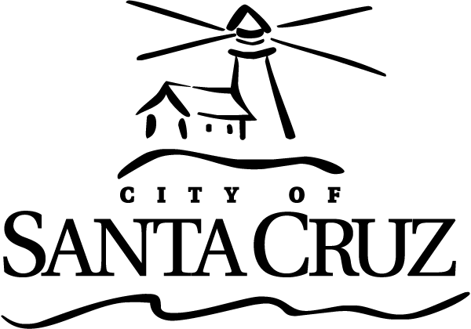 | CITY OF SANTA CRUZ  809 Center Street  Santa Cruz, California 95060

TRANSPORTATION AND PUBLIC WORKS COMMISSION (TPWC)
Regular Meeting

June 15, 2020

6:00 p.m. | General Business and Matters of Public Interest, Council Chambers
Commission meetings are audio recorded and will be posted to the Advisory Body webpage following the meeting.

Written material for every item listed on the agenda is available for review at the Public Works office, 809 Center Street, Room 201, and online at www.cityofsantacruz.com.

COVID-19 ANNOUNCEMENT: This meeting will be held via teleconference ONLY.

In order to minimize exposure to COVID-19 and to comply with the social distancing suggestion, the Council Chambers will not be open to the public. The meeting may be viewed remotely, using the following source:
Online through Zoom at: https://zoom.us/j/91624156100

PUBLIC COMMENT and ORAL COMMUNICATIONS:
If you wish to comment on items 1-7, please see information below. Call at the start of the item you wish to speak on.

- Call any of the numbers below. If one is busy, try the next one.
  - 1-833-548-0276 (Toll Free)
  - 1-833-548-0282 (Toll Free)
  - 1-877-853-5247 (Toll Free)
  - 1-888-788-0099 (Toll Free)
  - 1-669-900-9128
  - 1-346-248-7799
  - 1-253-215-8782
  - 1-301-715-8592
  - 1-312-626-6799
  - 1-646-558-8656
- Enter the meeting ID number: 916 2415 6100
- When prompted for a Participant ID, press #.
- Press *9 on your phone to “raise your hand” when the Chair calls for public comment.
  - It will be your turn to speak when the Chair unmutes you. You will hear an announcement that you have been unmuted. The timer will then be set to 3 minutes
  - You may hang up once you have commented on your item of interest, or if you wish to speak on another item, stay on the line and press *9 again when you are ready to speak on your next item of interest.

Time limits set by Commission Policy are guidelines. Unless otherwise specified, procedures for all items, are:
- Oral staff report
- Public comment - 3 minutes each; maximum total time may be established by the Presiding Officer at the beginning of an agenda item
- Commission deliberation and action

No action will be taken on items listed under Oral Communications, Announcements, Presentations, and Information Items

Appeals - Any person who believes that a final action of this advisory body has been taken in error, that decision may or may not be appealable to the City Council. Appeals must be in writing, setting forth the nature of the action and the basis upon which the action is considered to be in error, and addressed to the City Council in care of the City Clerk Administrator. Appeals must be received by the City Clerk Administrator within ten (10) calendar days following the date of the action from which such appeal is being taken. An appeal must be accompanied by a fifty dollar ($50) filing fee.

Additional Information
Visit the City’s Web Site at www.cityofsantacruz.com with links including City Advisory Body Meeting Agendas and Minutes, Advisory Body Information, and the Santa Cruz Municipal Code.
A copy of the full TPWC agenda, agenda reports and attachments which are included in the meeting packet, are available for review at the Central Library on Church Street no later than three (3) days prior to the meeting date.
The City of Santa Cruz does not discriminate against persons with disabilities. Out of consideration for people with chemical sensitivities, we ask that you attend fragrance free. If you wish to attend this public meeting and will require assistance, such as an interpreter for American Sign Language, Spanish, or other special equipment, please call the Public Works Office at (831) 420-5162 or e-mail sruble@cityofsantacruz.com at least five (5) days in advance so that arrangements for such assistance can be accommodated. The Cal-Relay system number: 1-800-735-2922.
Any writing related to an agenda item for the open session of this meeting distributed to the TPWC less than 72 hours before this meeting is available for inspection at the Public Works Department at 809 Center Street, Room 201. These writings will also be available for review at the TPWC meeting in the Council Chambers.

Transportation and Public Works Commission (TPWC)

6:00 PM

Call to Order

Roll Call

Absent with Notification

Statements of Disqualification

Oral Communications

Announcements

Presentations

Approval of Minutes

1. | May 18, 2020 Transportation and Public Works Commission Draft Minutes

Consent

General Business

2. | Future of Bike Share, Scooters, and Shared Mobility

Motion that the Transportation and Public Works Commission deliberate the benefits and tradeoffs of future shared mobility system options and provide input on desired next step actions.

3. | Slow Streets Recommendation

Motion that the Transportation and Public Works Commission recommend that the City Council of Santa Cruz adopt a Slow Streets program to promote public health during the COVID-19 pandemic and direct the Transportation and Public Works Commission to develop program guidelines with guidance from Public Works Staff.

4. | Direction of the Transportation and Public Works Commission 2020 Project Open House Meeting

Motion that the Transportation and Public Works Commission request that staff prepare to hold the 2020 project open house meeting virtually or forgo a project open house meeting in 2020.

Information Items

5. | Resilient Coast Santa Cruz update

6. | Update on Budget and CIP Status

Subcommittee/Advisory Body Oral Reports

Items Initiated by Members for Future Agendas

Adjournment

