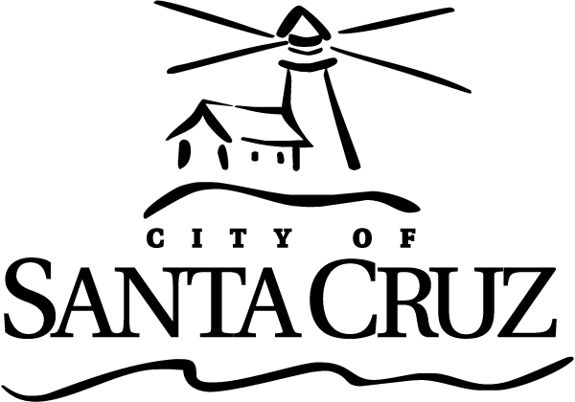 | CITY OF SANTA CRUZ  809 Center Street  Santa Cruz, California 95060

DOWNTOWN COMMISSION
Regular Meeting

May 27, 2021

8:30 A.M. | General Business and Matters of Public Interest, Council Chambers
Commission meetings are audio recorded and will be posted to the Advisory Body webpage following the meeting.

Written material for every item listed on the agenda is available for review at the Public Works office, 809 Center Street, Room 201, and online at www.cityofsantacruz.com.

COVID-19 ANNOUNCEMENT: May 27, 2021
In order to minimize exposure to COVID-19 and to comply with the social distancing suggestion, the Council Chambers will not be open to the public. The meeting may be viewed remotely, using the following source:
- Online through Zoom at: https://zoom.us/j/96501481833
PUBLIC COMMENT and ORAL COMMUNICATIONS:
If you wish to comment on items on the agenda
, please see information below. Call at the start of the item you wish to speak on.
- Call any of the numbers below. If one is busy, try the next one.
  - 1-669-900-9128
  - 1-346-248-7799
  - 1-253-215-8782
  - 1-301-715-8592
  - 1-312-626-6799
  - 1646-558-8656
  - 1-888-788-0099 (Toll Free)
  - 1-833-548-0276 (Toll Free)
  - 1-833-548-0282 (Toll Free)
- Enter the meeting ID number: 965 0148 1833
- When prompted for a Participant ID, press #.
- Press *9 on your phone to “raise your hand” when the Chair calls for public comment.
  - It will be your turn to speak when the Chair unmutes you. You will hear an announcement that you have been unmuted. The timer will then be set to 3 minutes
  - You may hang up once you have commented on your item of interest, or if you wish to speak on another item, stay on the line and press *9 again when you are ready to speak on your next item of interest.
Time limits set by Commission Policy are guidelines. Unless otherwise specified, procedures for all items, are:
- Oral staff report
- Public comment - 3 minutes each; maximum total time may be established by the Presiding Officer at the beginning of an agenda item
- Commission deliberation and action

No action will be taken on items listed under Oral Communications, Announcements, Presentations, and Information Items

Appeals - Any person who believes that a final action of this advisory body has been taken in error, that decision may or may not be appealable to the City Council. Appeals must be in writing, setting forth the nature of the action and the basis upon which the action is considered to be in error, and addressed to the City Council in care of the City Clerk Administrator. Appeals must be received by the City Clerk Administrator within ten (10) calendar days following the date of the action from which such appeal is being taken. An appeal must be accompanied by a fifty dollar ($50) filing fee.

Additional Information
Visit the City’s Web Site at www.cityofsantacruz.com with links including City Advisory Body Meeting Agendas and Minutes, Advisory Body Information, and the Santa Cruz Municipal Code.
A copy of the full DTC agenda, agenda reports and attachments which are included in the meeting packet, are available for review at the Central Library on Church Street no later than three (3) days prior to the meeting date.
The City of Santa Cruz does not discriminate against persons with disabilities. Out of consideration for people with chemical sensitivities, we ask that you attend fragrance free. If you wish to attend this public meeting and will require assistance, such as an interpreter for American Sign Language, Spanish, or other special equipment, please call the Public Works Office at (831) 420-5184 or e-mail bborguno@cityofsantacruz.com at least five (5) days in advance so that arrangements for such assistance can be accommodated. The Cal-Relay system number: 1-800-735-2922.
Any writing related to an agenda item for the open session of this meeting distributed to the DTC less than 72 hours before this meeting is available for inspection at the Public Works Department at 809 Center Street, Room 201. These writings will also be available for review at the DTC meeting in the Council Chambers.

Downtown Commission

8:30 AM

Call to Order

Roll Call

Statements of Disqualification

Announcements

1 | Introduction of New Transportation Manager: Nathan Nguyen

Oral Communications

2 | Rick Longinotti Letter

Presentations

3 | Go Santa Cruz Program Update

4 | Bike Share Program Update

5 | Outdoor Dining Update

6 | Covid-19/ Parking Operations Update

7 | Downtown Development Projects Update

Approval of Minutes

8 | January 28, 2021 Meeting Minutes
 | Motion to approve the January 28, 2021 minutes.

9 | March 25, 2021 Downtown Commission Meeting Minutes
 | Motion to approve the March 25, 2021 meeting minutes

General Business

10 | Creation of a Parking Rate & Revenue Strategy Ad Hoc Subcommittee
 | Motion for the Downtown commission to approve the formation of and membership to a Parking Rate & Revenue Strategy Ad Hoc Subcommittee, including up to three commissioners for a period not to exceed six months, to develop a revised Parking Rate & Revenue Strategy and bring back a recommendation(s) to the Commission.

11 | Creation/Recreation of an Outdoor Dining/ Parklet Program Ad Hoc Subcommittee
 | Motion for the Downtown commission to approve the formation of and membership to an Outdoor Dining/ Parklet Program Ad Hoc Subcommittee, including up to three commissioners for a period not to exceed six months to continue to work with Economic Development and Public Works staff on program recommendations.

12 | FY 2022-2026 Capital Investment Program Parking Enterprise Fund – Administrative Draft
 | Motion that the Downtown Commission review the FY 2022-2026 Public Works Parking Enterprise Fund Capital Investment Program and provide input to staff for City Council consideration.

13 | Recommendations from the Covid-19 Response Ad Hoc Subcommittee related to the Quarterly Parking Deficiency Fee
 | Motion recommending that the City Manager waive the June 2021 quarterly parking deficiency fee billing and consider reinstatement of the deficiency fees at a time when Parking Garages return to Occupancy levels of 70% or greater.

Information Items

Written Material

Subcommittee/Advisory Body Oral Reports

Items Initiated by Members for Future Agendas

Adjournment

