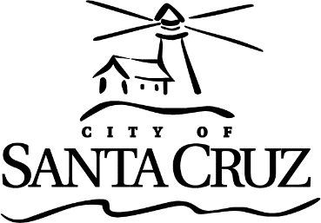 | CITY OF SANTA CRUZ  809 Center Street  Santa Cruz, California 95060

TRANSPORTATION AND PUBLIC WORKS COMMISSION
Regular Meeting

September 18, 2023

6:00 p.m. | General Business and Matters of Public Interest, Council Chambers
Commission meetings are audio recorded and will be posted to the Advisory Body webpage following the meeting.

Written material for every item listed on the agenda is available for review at the Public Works office, 809 Center Street, Room 201, and online at www.cityofsantacruz.com.

Time limits set by Commission Policy are guidelines. Unless otherwise specified, procedures for all items, are:
- Oral staff report
- Public comment - 3 minutes each; maximum total time may be established by the Presiding Officer at the beginning of an agenda item
- Commission deliberation and action

No action will be taken on items listed under Oral Communications, Announcements, Presentations, and Information Items

Appeals - Any person who believes that a final action of this advisory body has been taken in error, that decision may or may not be appealable to the City Council. Appeals must be in writing, setting forth the nature of the action and the basis upon which the action is considered to be in error, and addressed to the City Council in care of the City Clerk Administrator. Appeals must be received by the City Clerk Administrator within ten (10) calendar days following the date of the action from which such appeal is being taken. An appeal must be accompanied by a fifty dollar ($50) filing fee.

Additional Information
Visit the City’s Web Site at www.cityofsantacruz.com with links including City Advisory Body Meeting Agendas and Minutes, Advisory Body Information, and the Santa Cruz Municipal Code.
A copy of the full TPWC agenda, agenda reports and attachments which are included in the meeting packet, are available for review at the Central Library on Church Street no later than three (3) days prior to the meeting date.
The City of Santa Cruz does not discriminate against persons with disabilities. Out of consideration for people with chemical sensitivities, we ask that you attend fragrance free. If you wish to attend this public meeting and will require assistance, such as an interpreter for American Sign Language, Spanish, or other special equipment, please call the Public Works Office at (831) 420-5160 or e-mail TPWC@santacruzca.gov at least five (5) days in advance so that arrangements for such assistance can be accommodated. The Cal-Relay system number: 1-800-735-2922.
Any writing related to an agenda item for the open session of this meeting distributed to the TPWC less than 72 hours before this meeting is available for inspection at the Public Works Department at 809 Center Street, Room 201. These writings will also be available for review at the TPWC meeting in the Council Chambers.

Transportation and Public Works Commission (TPWC)

6:00 PM

Call to Order

Roll Call

Absent with Notification

Statements of Disqualification

Oral Communications

Announcements

Presentations

Approval of Minutes

1. | Approval of Minutes for the August 21, 2023 Transportation and Public Works Commission Meeting.
 | Motion that the Transportation and Public Works Commission approve the August 21, 2023 – Transportation and Public Works Commission Draft Minutes.

Consent

General Business

2. | METRO Interim Downtown Transit Center Plan
 | Motion that the Transportation and Public Works Commission review, provide comments, and recommend that the City Council approve the METRO Interim Downtown Transit Center Plan.

Information Items

Subcommittee/Advisory Body Oral Reports

Items Initiated by Members for Future Agendas

Adjournment

